# Artificial Intelligence Masterclass

## Hybrid Intelligent System

.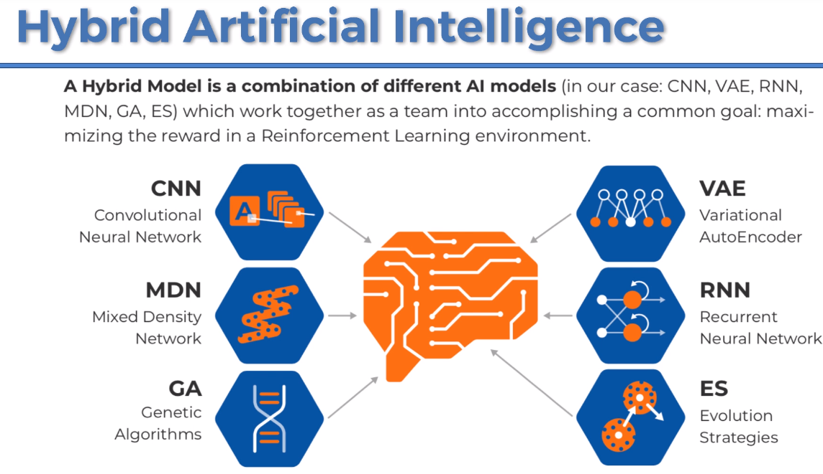

This hybrid combination of State of the art Mole's is going to be optimized by deep neuro evolution and deep neuro evolution as the brand-new era of artificial intelligence. These are some powerful optimizers which will find the best parameters meaning the best weights of the neural networks inside your AI.

And the best ones that we have today are genetic algorithms and evolutions strategies and of course the moral that will build in this course and that will play against India and is optimized by the best technique of deep neuro evolution which is evolution strategy and more specifically it will be what we call covariance matrix adaptation evolution strategy



As you can see it is a hybrid intelligence system combining a convolutional neural network that allows AI to see a variational or encoder that allows AI to dream or record a neural network with mixture density network that allows ai to remember you know like it has memory.

Then you have a controller that allows to review the right actions to play in maximize that reward in an AI environment. And on top of that you have the powerful optimizers of deep neuro evolution among which the most powerful ones are.

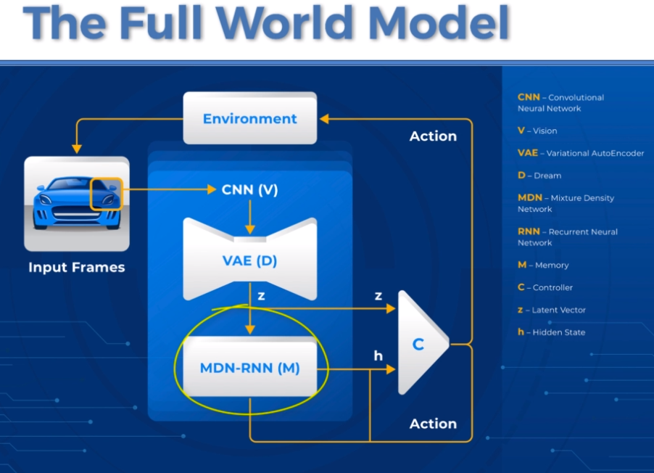

## Course Structure

10 steps with one Udemy section per step.

1. **ANN**: To understand the convolutional neural network CNN you have to understand first the artificial neural network and that's why the first step of this plan of attack is to study the artificial neural network.
2. **CNN**: Once you understand the artificial neural network you'll be able to move on to Step Two convolutional neural network and then we continue our journey and we follow the path the next step as we can see on this graphic representing the full world model is to study the Variational AutoEncoder
3. **AutoEncoder**: Before you understand the Variational AutoEncoder you have to understand first the code itself which is exactly you go into the step three of this plan of attack
4. **Variational AutoEncoder**: Once you understand our encoder Well then you will be able to understand variational our encoder which therefore will be the step 4 of this course structure.
5. **Implement CNN-VAE**: Implement the CNN-VAE and the that is a variational AutoEncoder for which the first layer is in a deep neural network will be of course a convolutional neural network. And that's why what we're going to implement is not a general VAE but a CNN-VAE. And we will implement that with both tensorflow and cast(Huh?).
6. **Recurrent Neural Network**: Next step in the process you must understand first the recurrent neural network because an MDN-RNN is nothing else than a recurrent neural network for which the hidden states are sampled by a mixture density network.
7. **Mixture Density Network**:
8. **Implementing the MDN-RNN** and implement it from scratch using Python. (Need to use Keras and R to replicate this code)
9. **Reinforcement Learning:** combine all this to play better and better actions in order to drive faster and faster
10. **Deep NeuroEvolution** (GA, ES): Era of the hybrid artificial intelligence systems optimized by Deep NeuroEvolution. CMES optimizer (**c**ovariance **m**atrix **e**volution **s**trategy). Deep NeuroeEvolution covering the most powerful techniques which are genetic algorithms and evolution strategies.

## Resources

1. 
2. <https://worldmodels.github.io/>   
   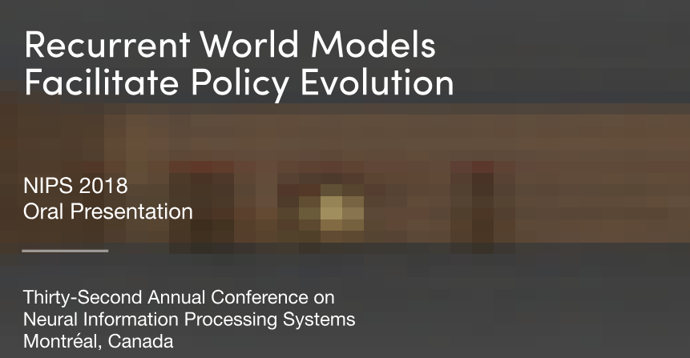  
   Keep this open during the course
3. <http://blog.otoro.net/2017/10/29/visual-evolution-strategies/>   
   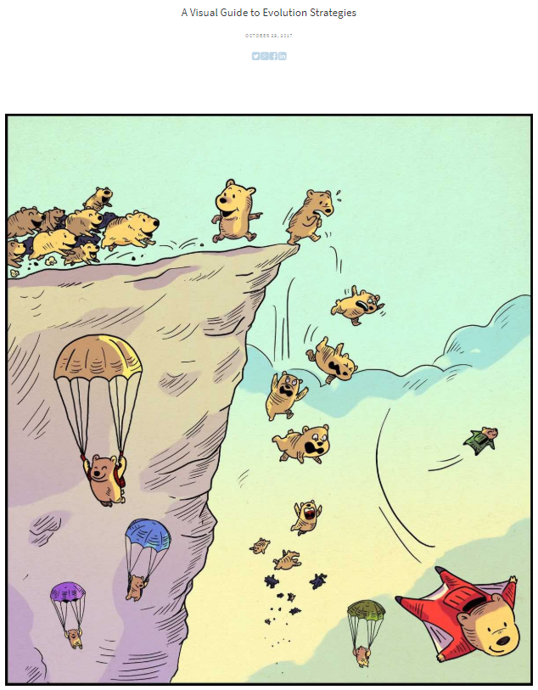

# Artificial Neural Networks

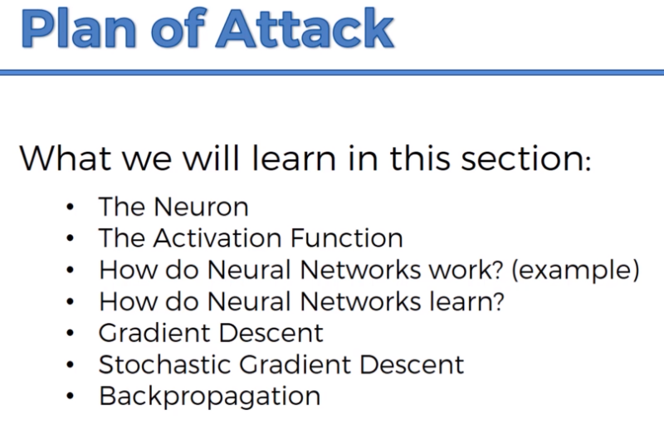

## The Neuron

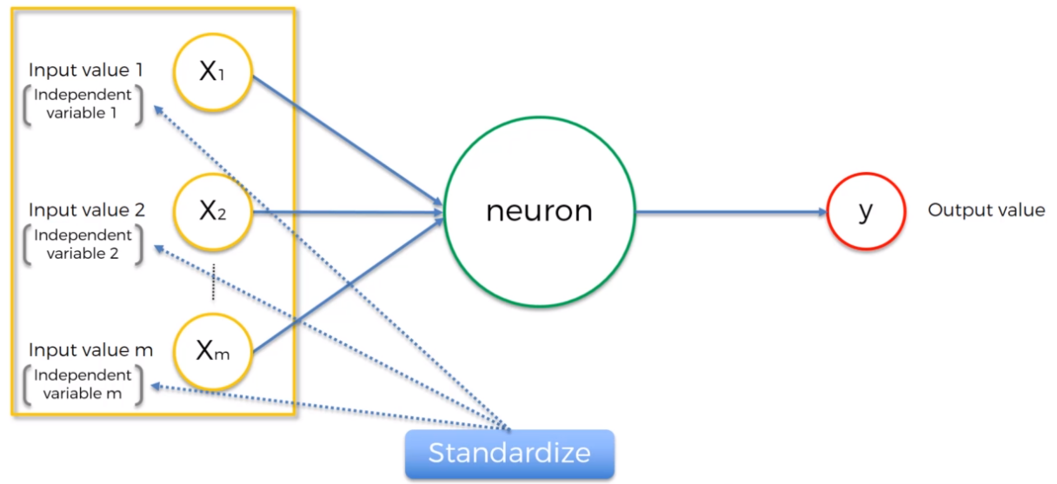

These inputs which are in fact independent variables so it depends variable one the debate variable to depend. Well the important thing to remember here is that these independent variables are all for one single observation. Think of it as just one row in your database. One observation you just take all of the independent variables you know maybe it's the age of the person there the amount of money in the bank accounts and then how do they drive or walk to work.

And the other thing you need to know about these variables is that you need to standardize (or normalize) them so you need to standardize them which means make sure that they have a mean of zero and variance one.

To normalize, subtract the minimum value and then you divide by the maximum minus minimums or by the range of your values and the four you get values between 0 and 1.

It depends on this scenario you might want to do one or the other.

## Activation Function

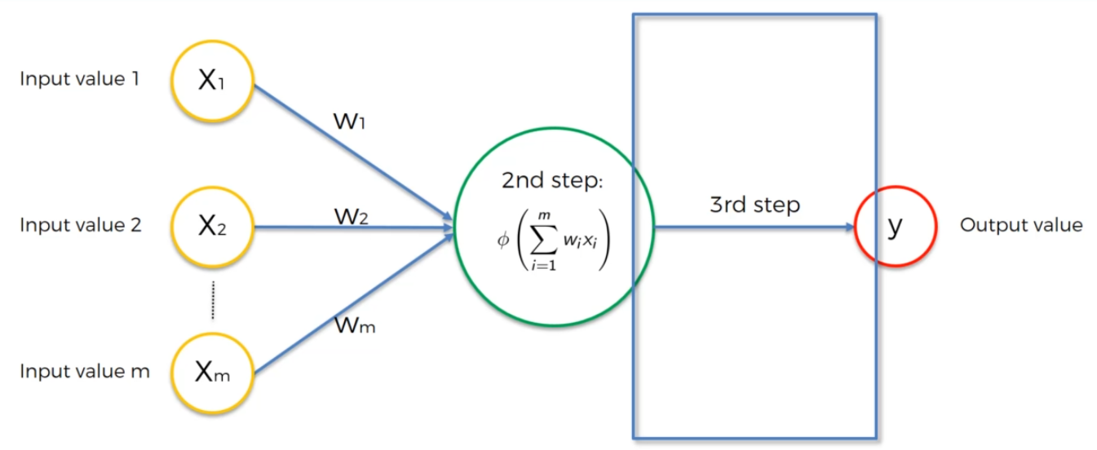

Activation function is applied after the weights have been summed.

Types of functions:

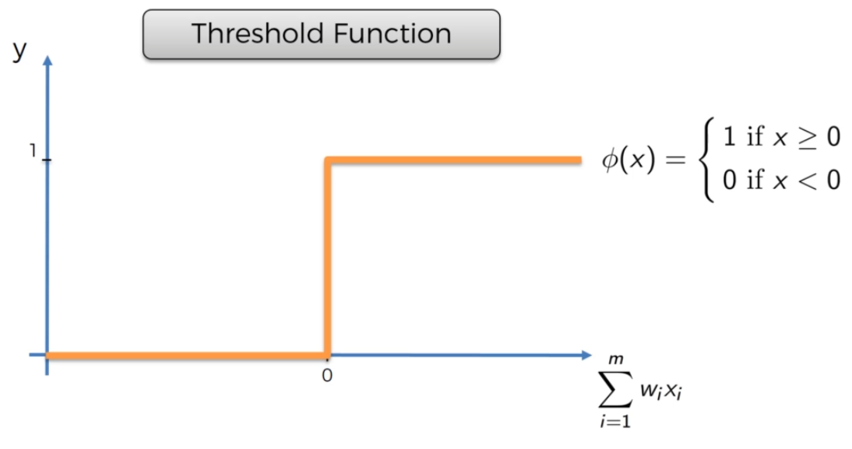

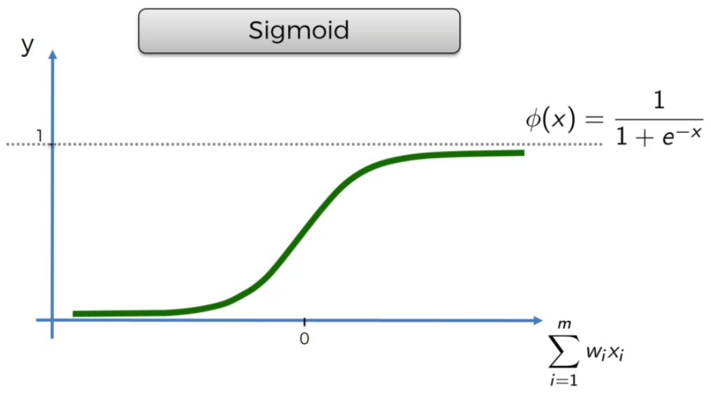

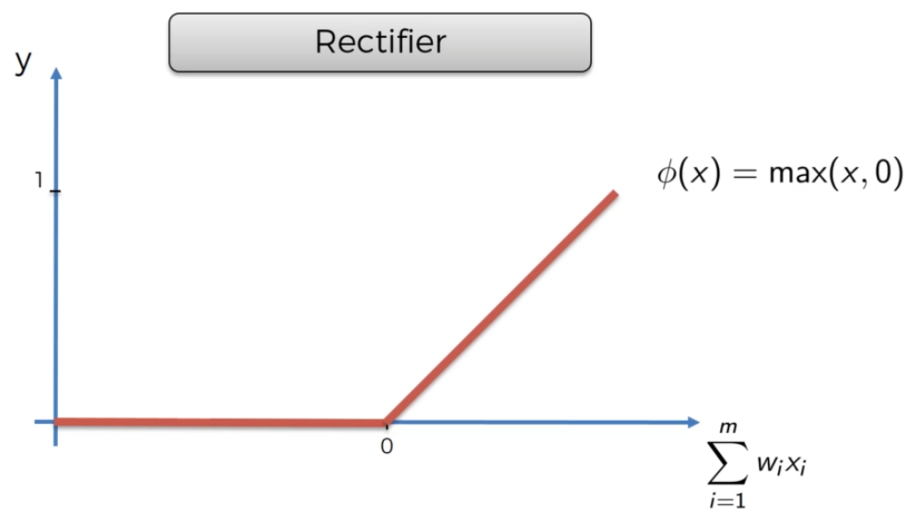

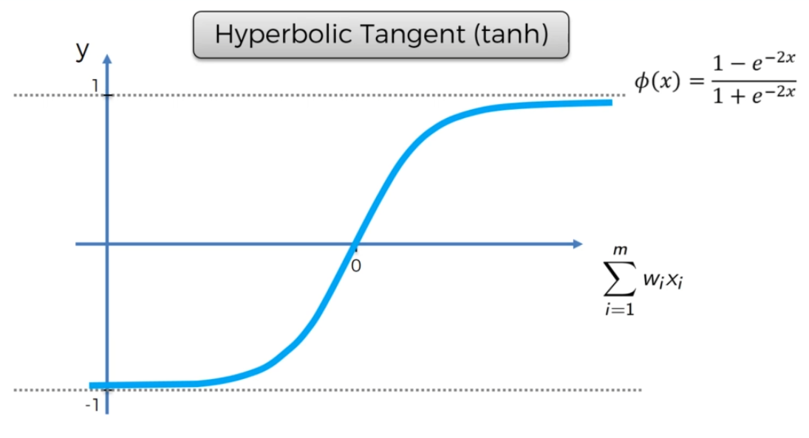

Similar to sigmoid but supports negative values to -1.

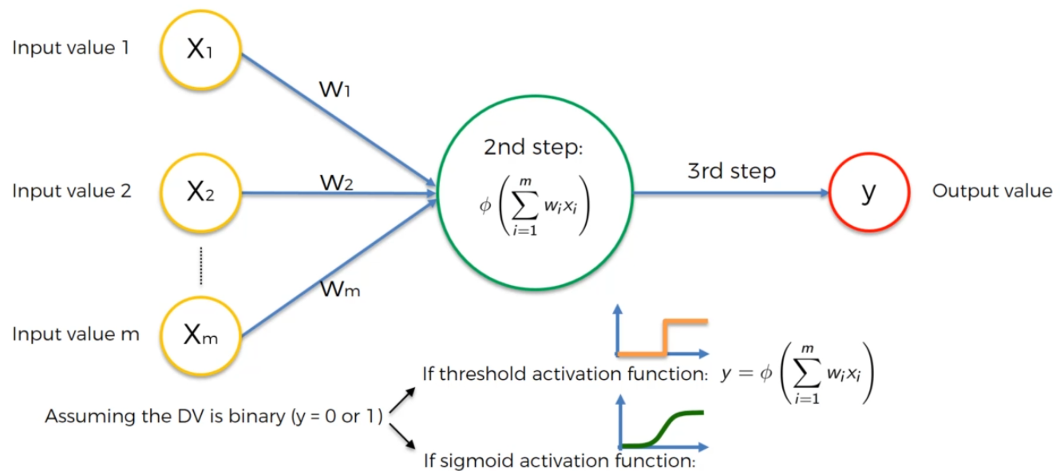

Note sigmoid also has a range between ) and 1. Gives you a probability.

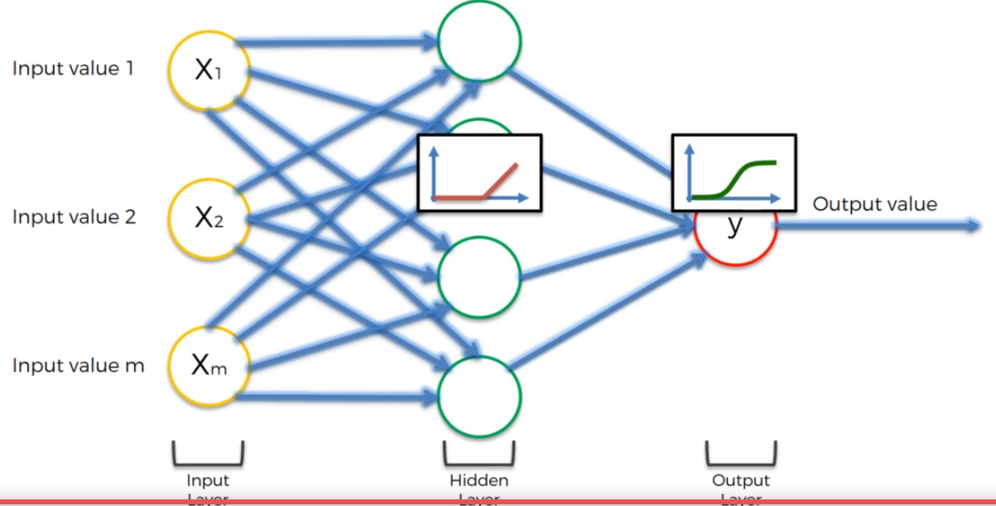

This is a common design

## How Do NN Work?

Measure property values to serve as an example. The model has already been trained; this focuses only on how it works.

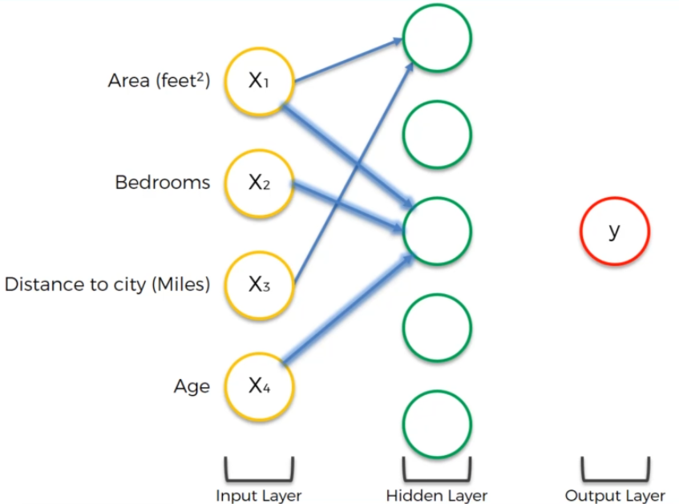

Certain hidden nodes find interesting weights – this all happens during training

Perhaps the neuron found the combination of Area and Distance interesting

Then Area, Bedrooms and Age work together to maximize y

The model can find relationships that a human may not be able to do. These combinations create relationships that we could never do.

## How Do NN Learn?

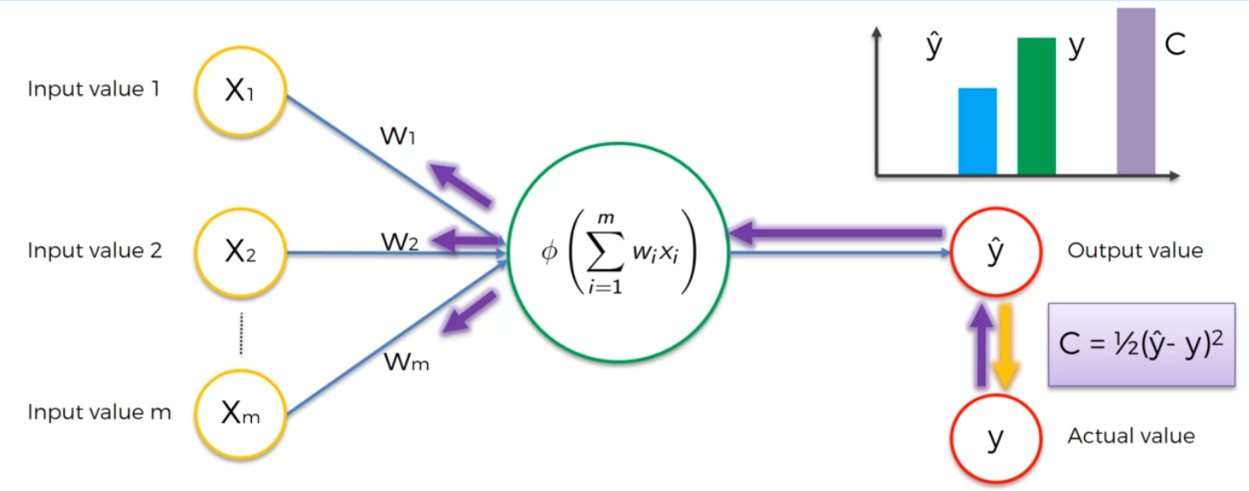

Minimize the error as defined by cost function (many choices)

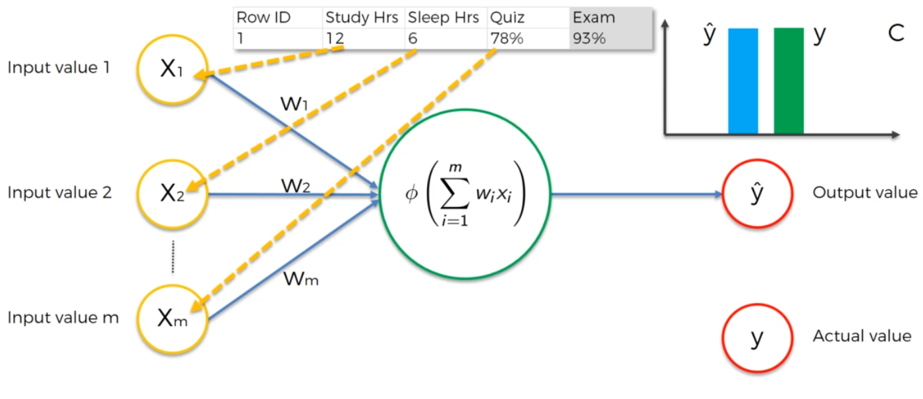

What about multiple records?

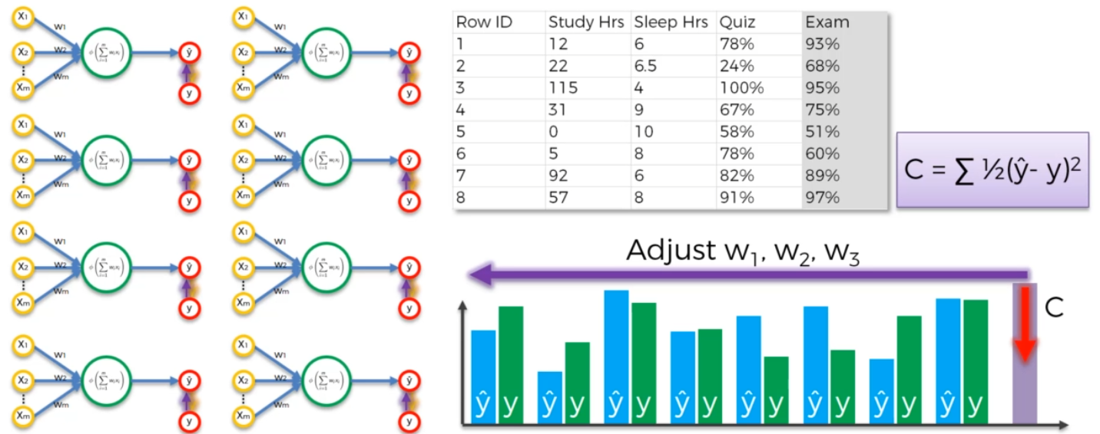

Iterate to minimize the total cost function (backpropogation)

## Stochastic Gradient Descent

Regular or batch gradient Descent collects the sum error for all the records then adjusts weights.

In Stochastic Gradient Descent, each weight is updated for each record.

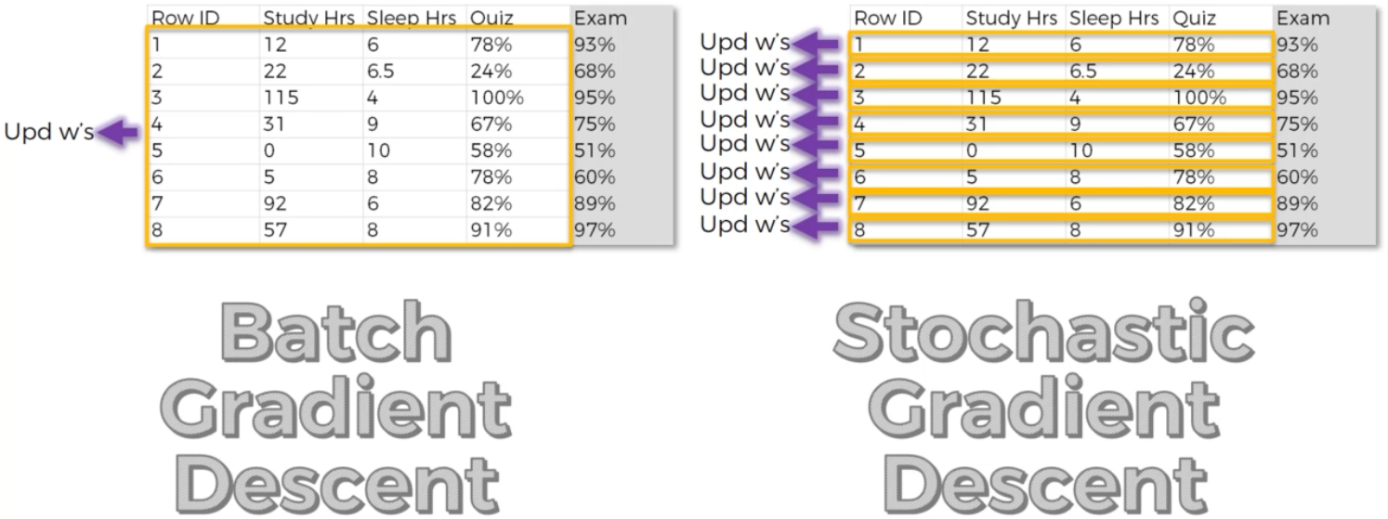

Stochastic Gradient Descent has larger fluctuations and is more likely to find a global minimum rather than settling on a local minimum.

Bath Gradient Descent is deterministic if you start with the same initial weights.

## Backpropogation

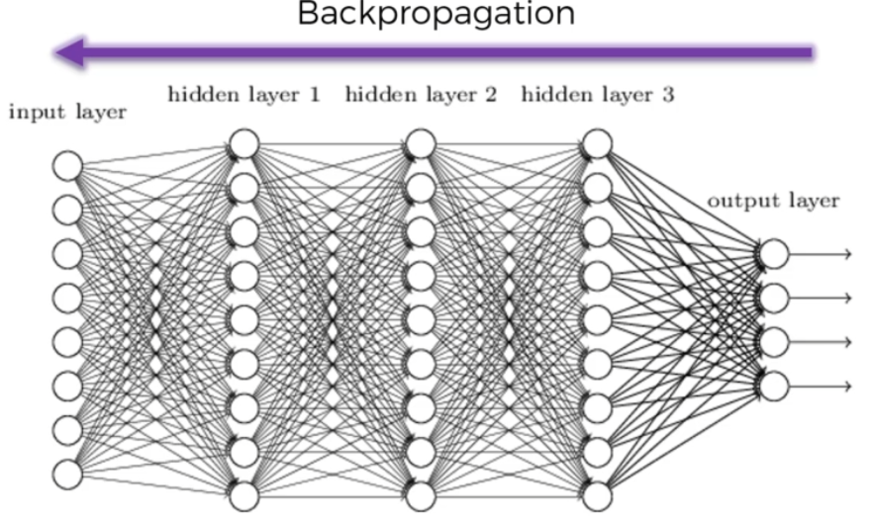

All weights are updated at the same time.

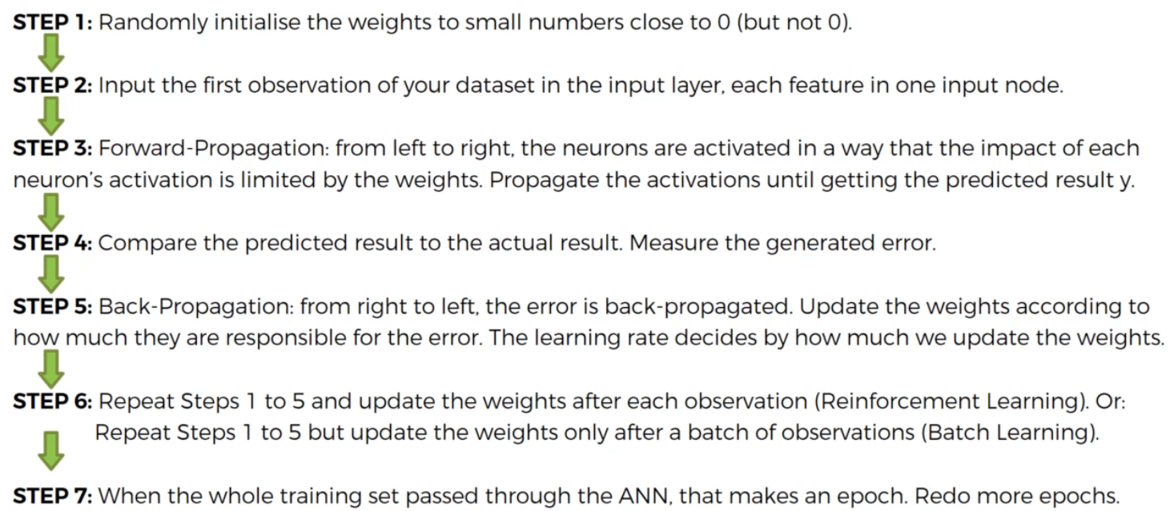

# Convolutional Neural Networks

1. What are CNNs?
2. Convolution Operation
3. ReLU Layer
4. Pooling
5. Flattening
6. Full Connection
7. Extra: Softmax & Cross-Entropy

## What are CNNs?

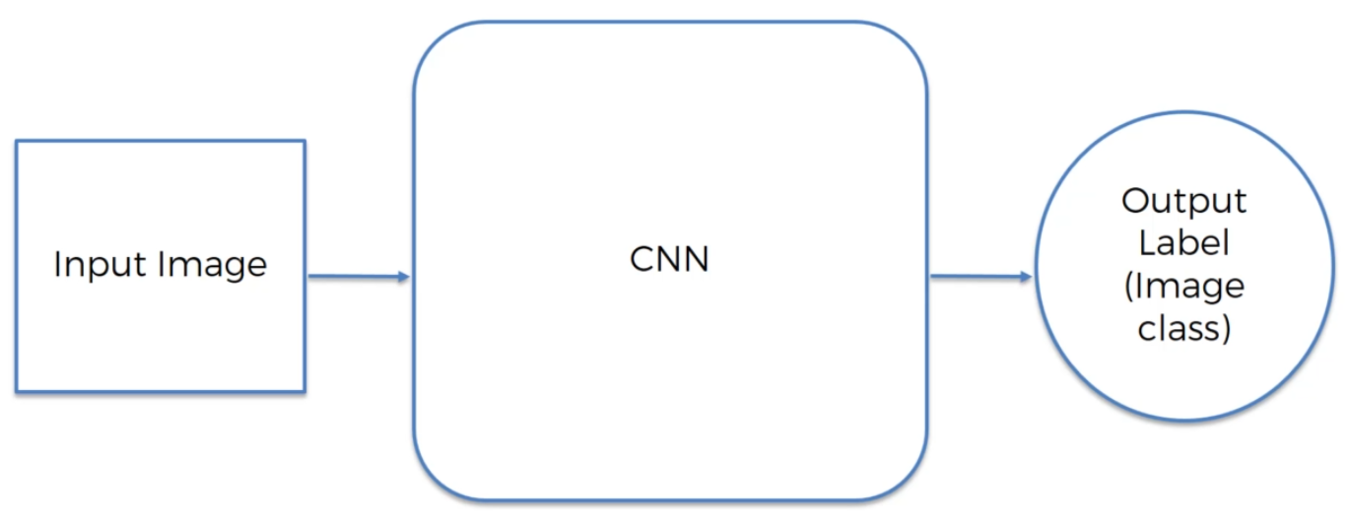

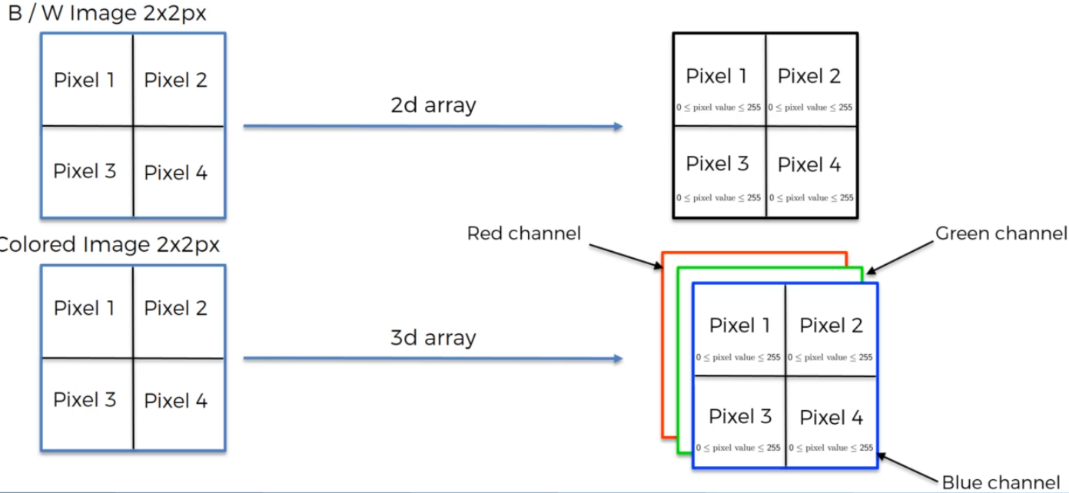

Super simple example:

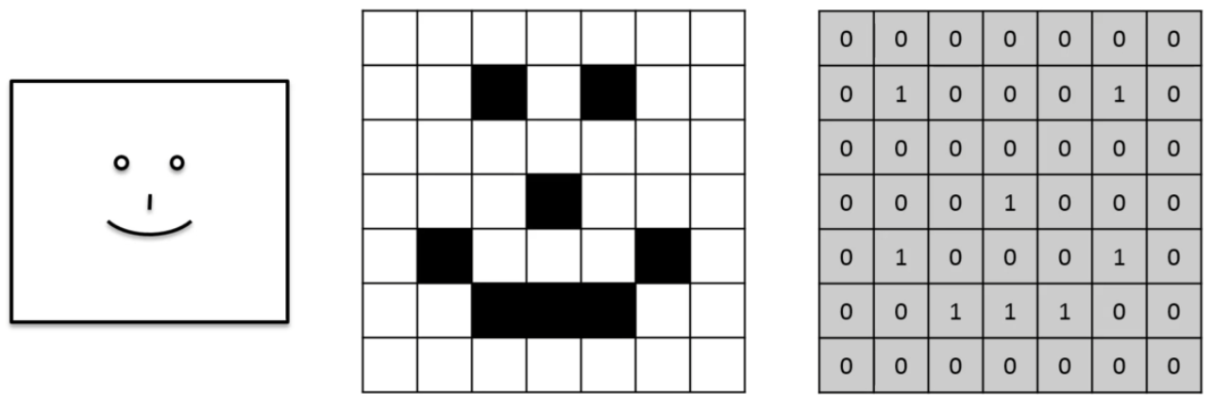

## Convolution Operation

This is the first step on developing a CNN

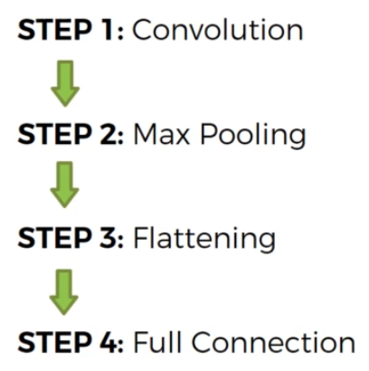

Feature detectors are typically three by three and they are you know reasons to make them three by three so we're going to stick to the conventional way. Having a three by three feature detector also the feature detectors called these are important terms because you might come across them.

There are many different terms for the feature detector but the most common ones are feature detector or you might hear it being called kernel or you might hear it being called Filter.

When you move from pixel to pixel in the input image, this is called the stride. The this example the stride is 1 but most commonly a stride of 2 is used.

Below, you enter values into the Feature Detector by doing a summation of each pixel-pixel multiplication. Since noting matches, a 0 is entered on the feature map.

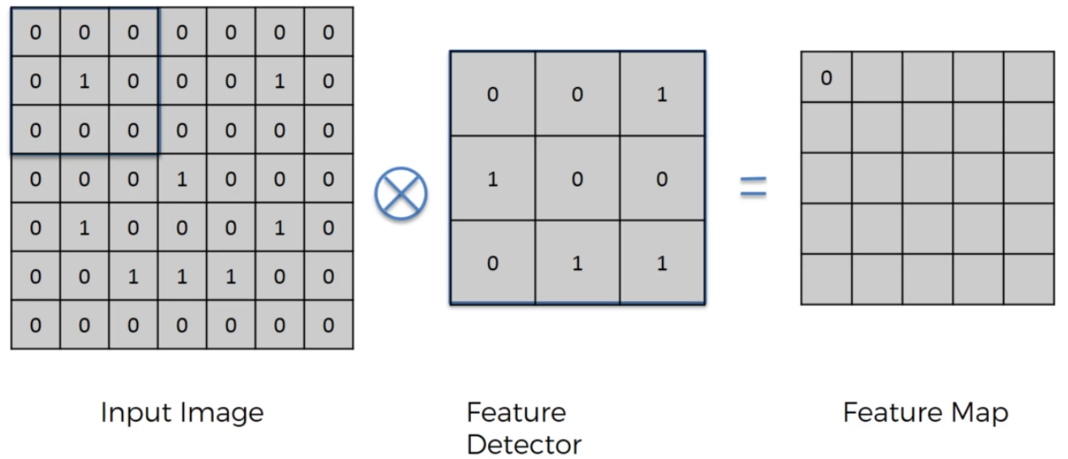

There is a match once you select the 2nd pixel in the input image (2nd row, 1st column):

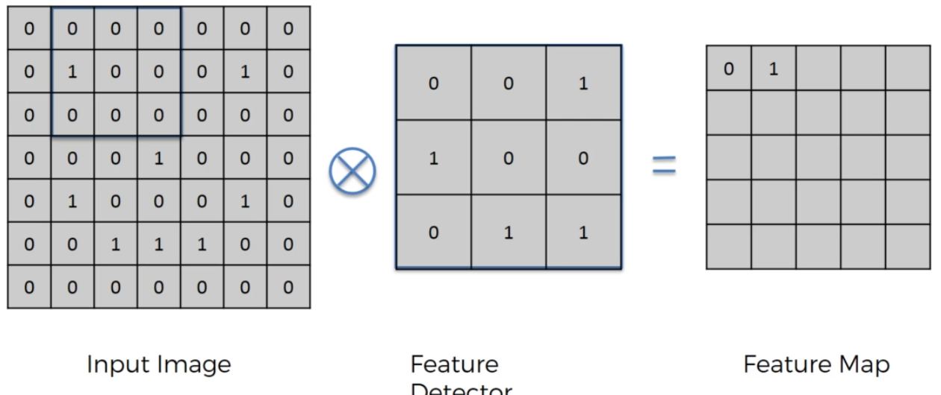

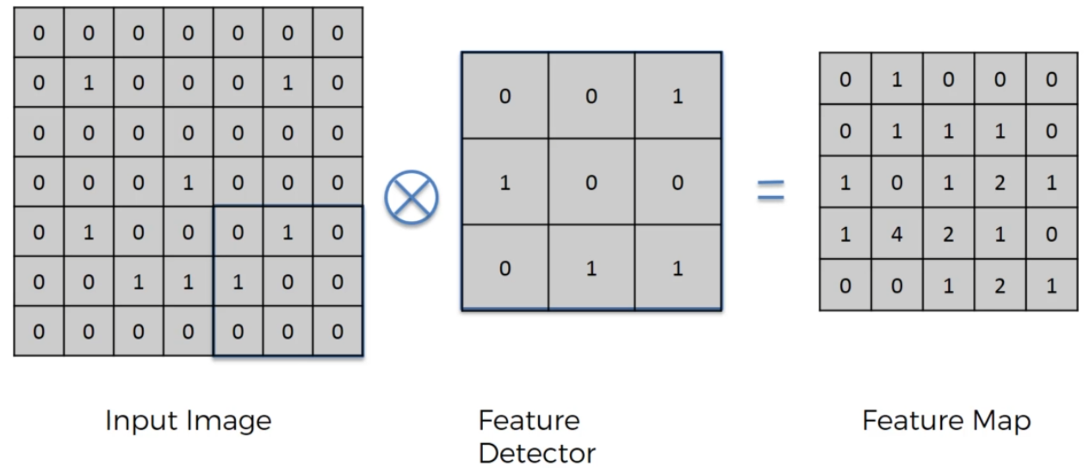

Feature Detector is sometimes called Convolded Feature or Activation Map.

What is achieved from this process:

* Reduces image size
* A stride of 2 makes the feature map even smaller
* We do lose some information using feature detector
* Features is how humans see, this is being preserved because the feature detector identifies the highest values in the Feature Map. (In the example above, there is 1 instance where the highest value possible -4 – is found.

Many feature maps are created by using different filters (Feature Detectors).

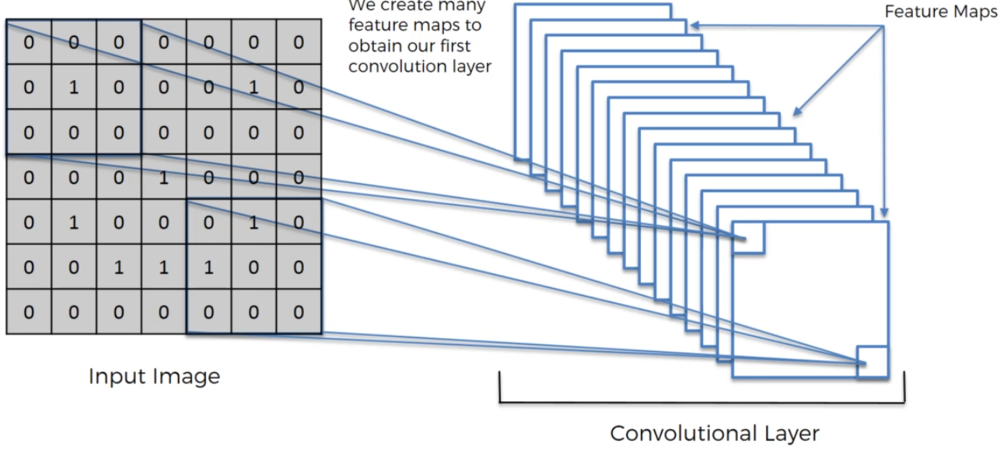

The primary purpose of convolution is to find features in your image using the feature detector put them into a feature map and by having them in a future map it still preserves the spatial relationships between pixels which is very important for us to you know because if they are completely jumbled up then we have we've lost the pattern.

And at the same time it's important to understand that most of the time the features a neural network will detect and use to recognize certain images and will mean nothing to humans but nevertheless they work.

And that's what evolution is.

## ReLU Layer

ReLU = Rectified Linear Units

Using the rectifier increases non-linearity in the image because images themselves are highly non-linear.

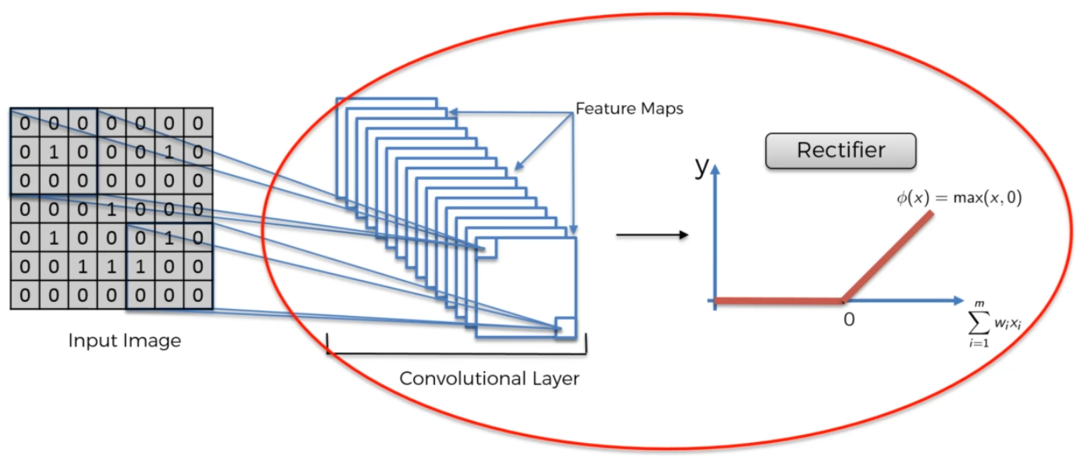

Aside: Microsoft proposed a better preforming rectifier called the parametric rectified function:

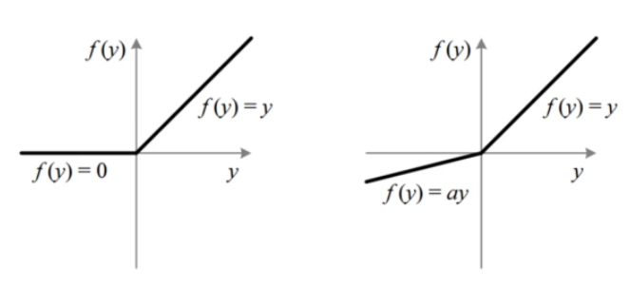

## Max Pooling

It helps identify features even when the specific feature us different – like diff picture of the same animals.

It like using another feature map but you find the max value, not the sum of values:

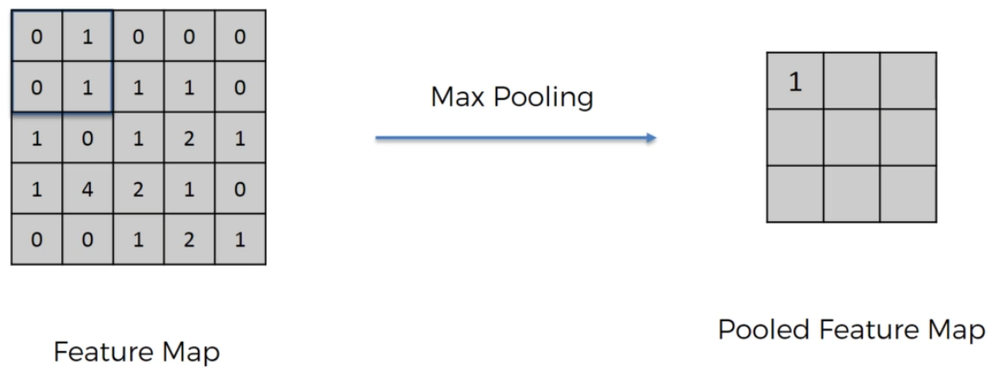

Using a stride of 2:

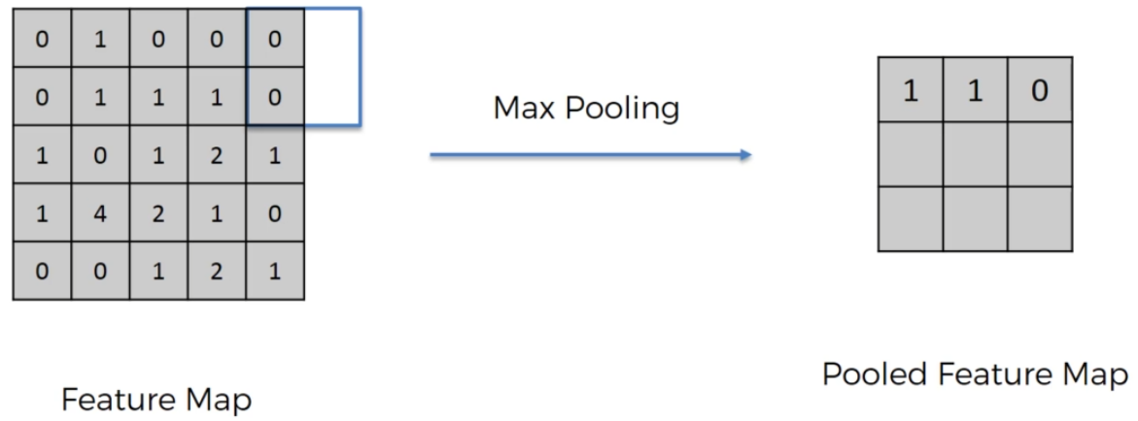

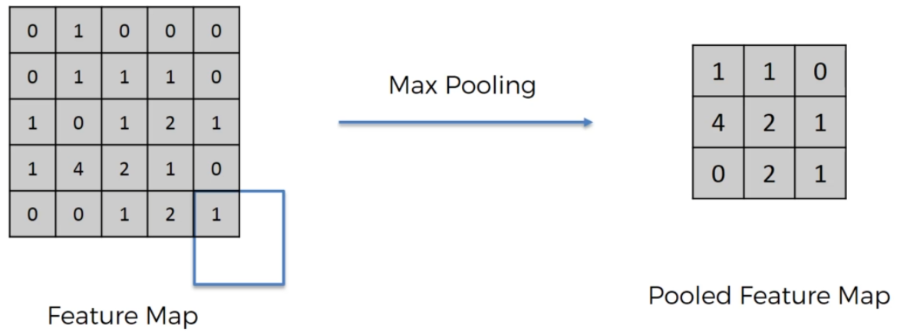

This removes the unimportant features while keeping the most important information. This process also helps to understand distortion or other spatial distortion.

* preserves the features we're introducing spatial invariants
* reducing the size by 75 percent which is huge
* reducing the number of parameters so we are reducing again by 75 percent or reducing number of parameters that are going to go into our final layers of the neural network
* we're preventing overfitting. It is a very important benefit of pooling that we're removing information and that is a good thing. That is a good thing because that way our model won't be able to over fit onto that information because especially because that information is not real

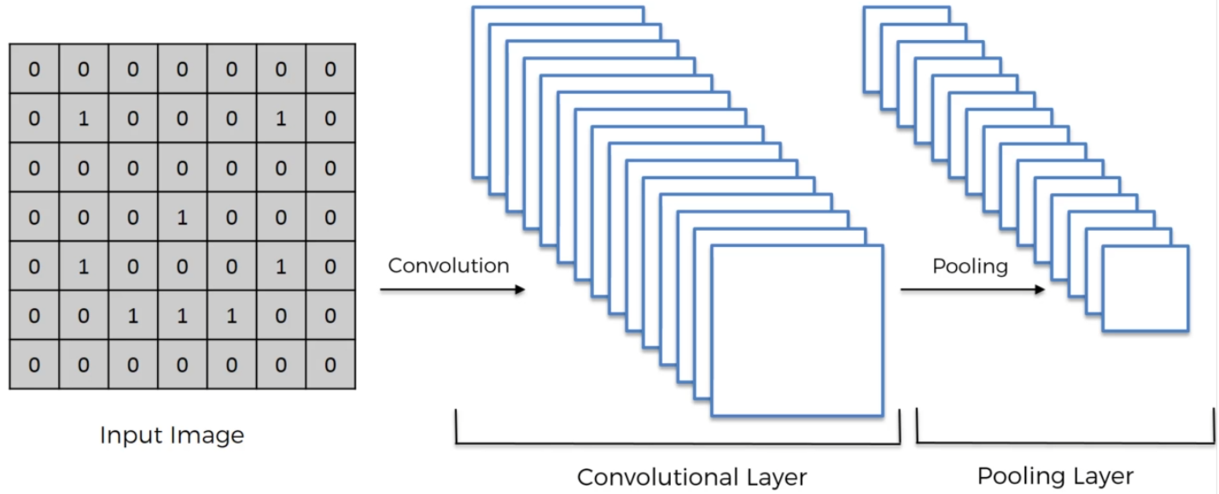

Pooling = downsampling

## Flattening

A simple step. . . .

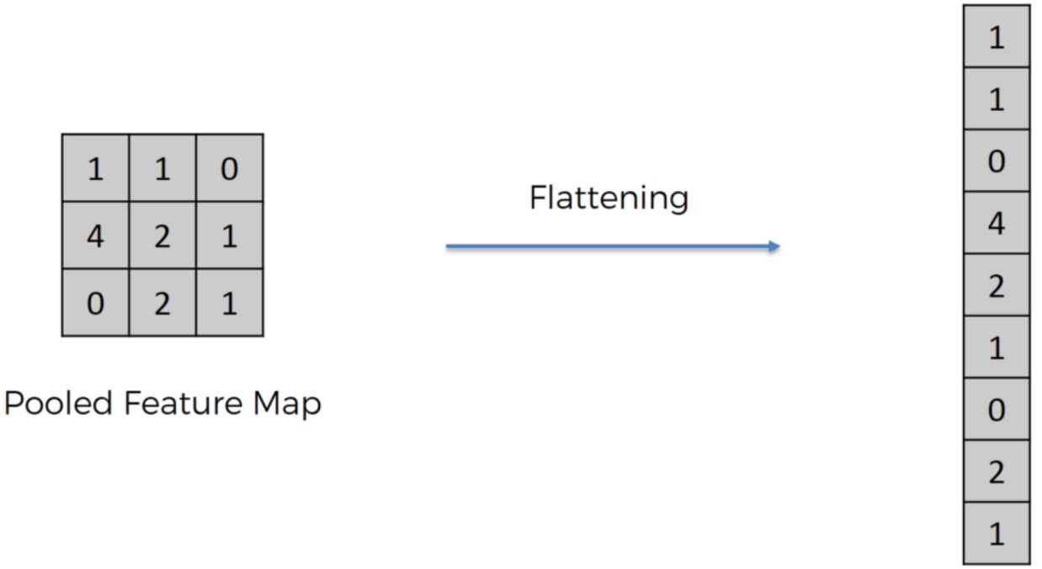

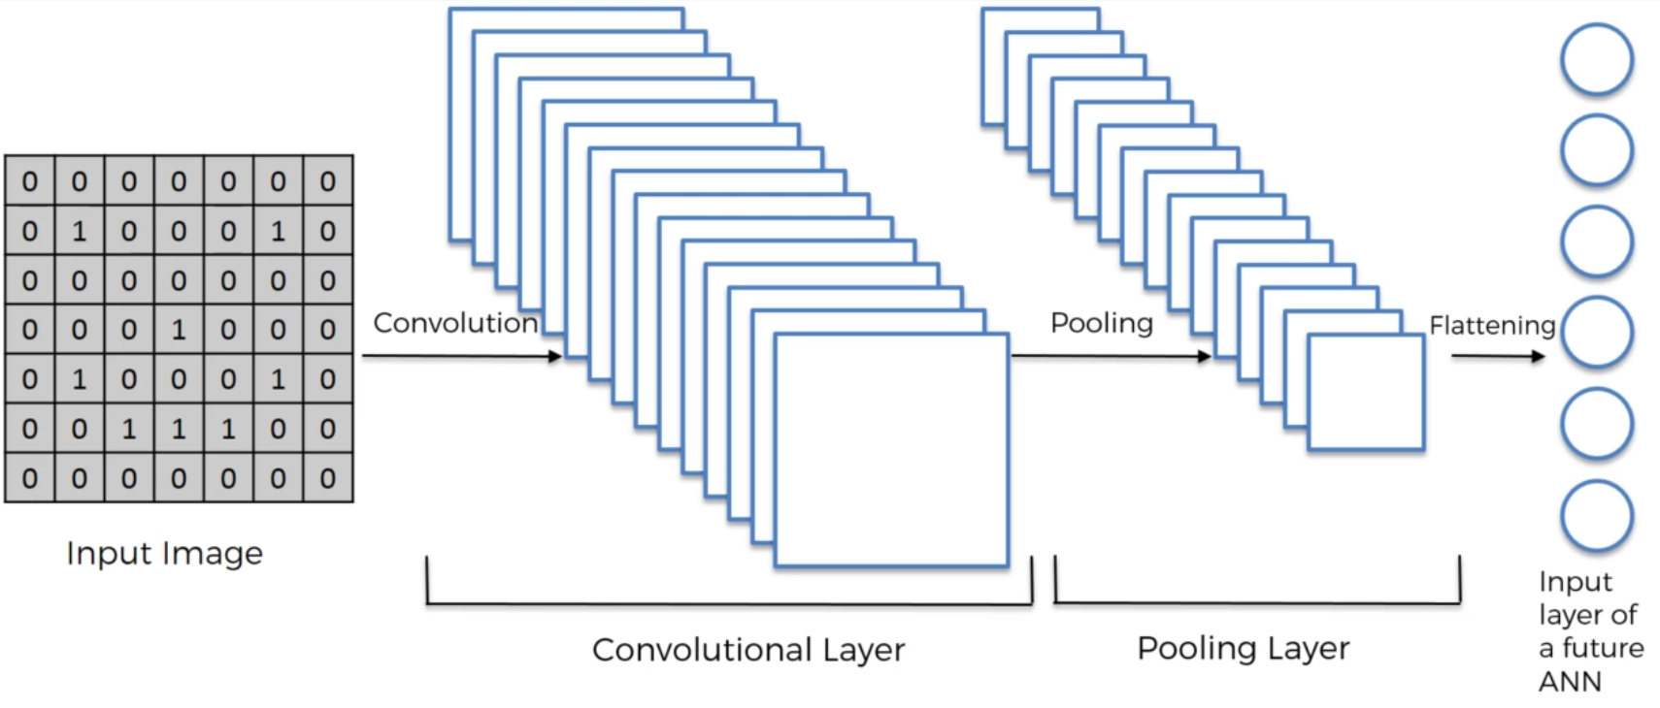

## Full Connection

## Extra: Softmax & Cross-Entropy

Adding an ANN after flattening. A fully connected layer is a special type of hidden layer. In ANN layers do not need to be fully connected.

The flattened vector data becomes the input to the ANN to optimize classification.

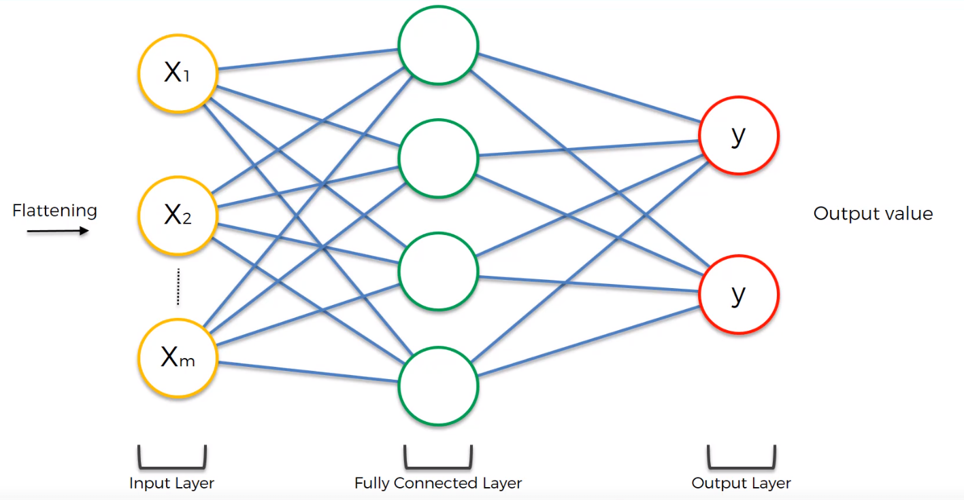

Of course, there can be more than one fully connected layers:

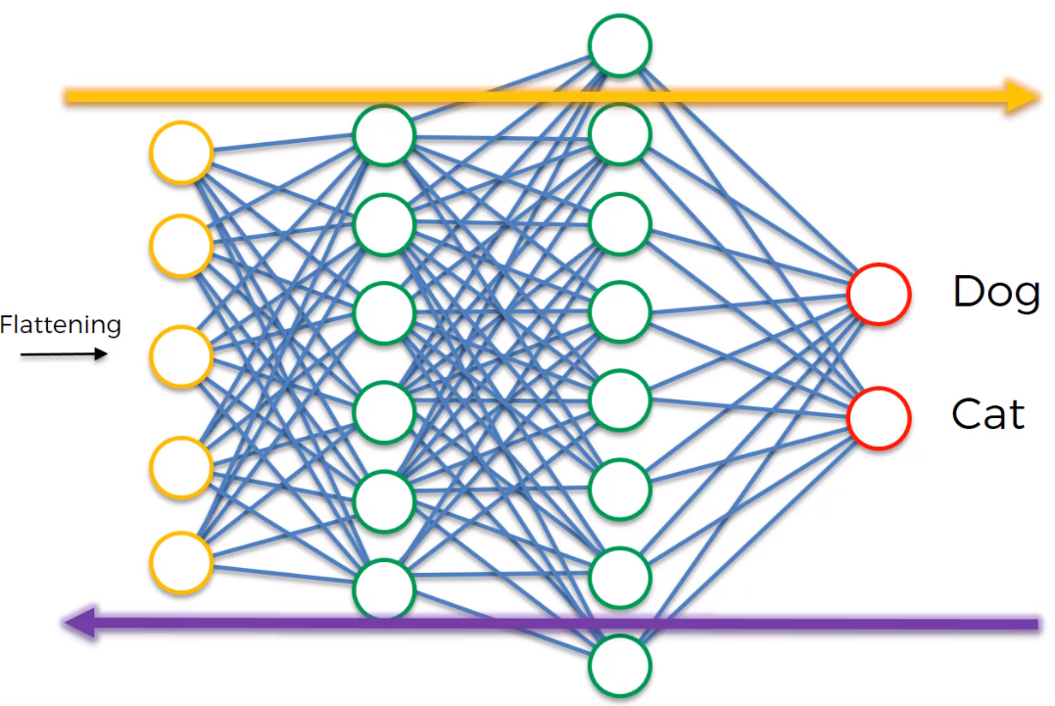

Feature detectors are adjusted during back propagation just as the ANN weights are.

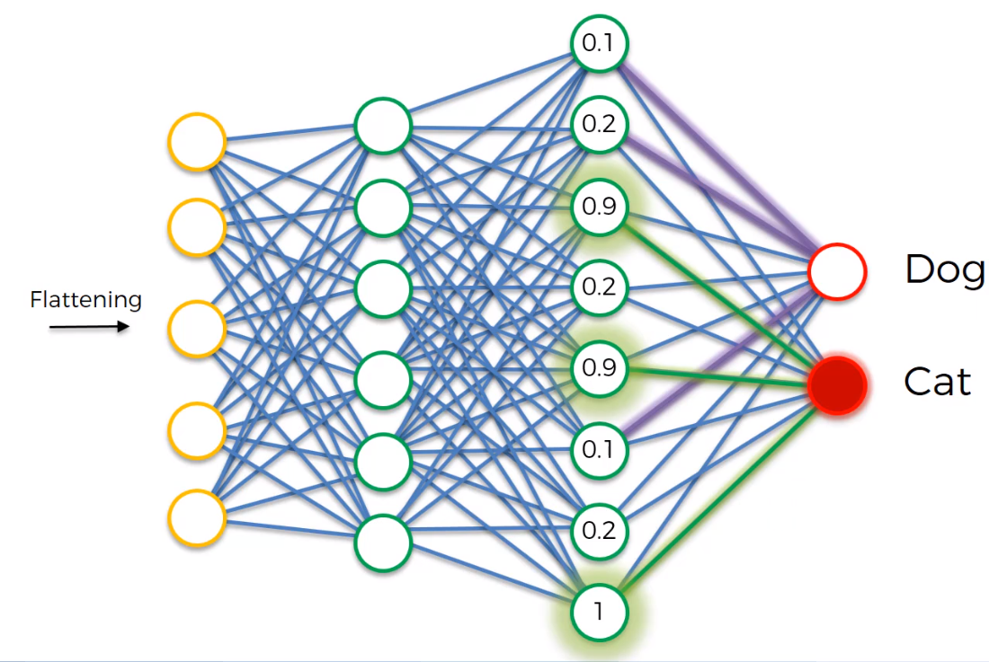

Even though the outputs are fully connected, over many epochs, the DOG learns which neurons result in a successful classification. The DOG and CAT learn which neurons impact classification the most.

The weights in the last fully connected layer are used in the classification voting.

## CNN Summary

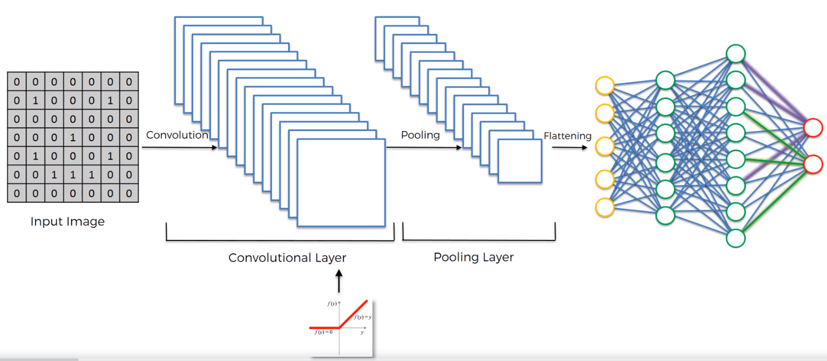

We started with an input image to which we applied multiple different feature detectors or also called filters to create these feature maps. And this comprises our convolutional layer.

Then on top of that convulutional there we applied the loo or rectified linear unit to remove any energy or increase non-linearity in our images. Then we applied a pooling layer to our kind of delusional there.

So from every single feature map we created a pooling feature map and basically the pooling layer has lots of advantages.

The main purpose of the pooling layer is to make sure that we have a special spatial invariance in our images. So if something tilts or twists or is a bit different to the ideal scenario then we can still pick up that feature plus pooling significantly reduces the size of our images are also pooling helps with avoiding any kind of overfitting of our data or overall model to the data because it just simply gets rid of a lot of that data.

But at the same time pooling preserves the main features that we're after just because the way instruction and the pooling were used was Max pooling.

Then we flattened all of the pooled images into one long a vector or a column of all of these values and we put that into an artificial neural network and that was Step Three flattening and Step four is a fully connected artificial neural network where all of these features are processed through a network and then we have this final fully connected layer which performs the voting towards the classes that we're after and then all of this is trained through a forward propagation and back propagation process.

And lots of lots of iterations and epochs and in the end we have a very well defined neural network and the computer.

Another important thing is not only the weights are trained in artificial neural network part but also the feature detectors are trained and adjusted in that same and gradient descent process and that allows us to come up with the best feature maps. And in the end we get a fully trained convolutional neural network which can recognize images and classify them.

## Extra: Softmax & Cross-Entropy

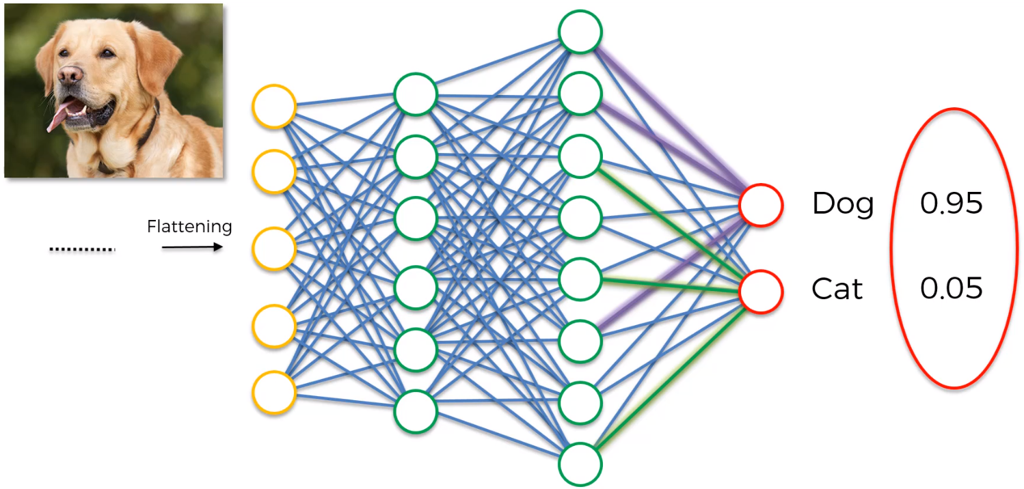

Why do the values add to 1? There is learned nothing so far that demands this.

Apply the softmax function which is written up over there at the top and that would bring these values to be between 0 and 1. And it would make them add up to 1. The soft next function or the normalized exponential function is a generalization of the logistic function that *squashes aka dimensional vector of arbitrary real values to a k dimensional vector of real values in the range of zero to one that add up to 1.*

SoftMax brings these values to be between 0 and 1 and make sure that they add up to 1.

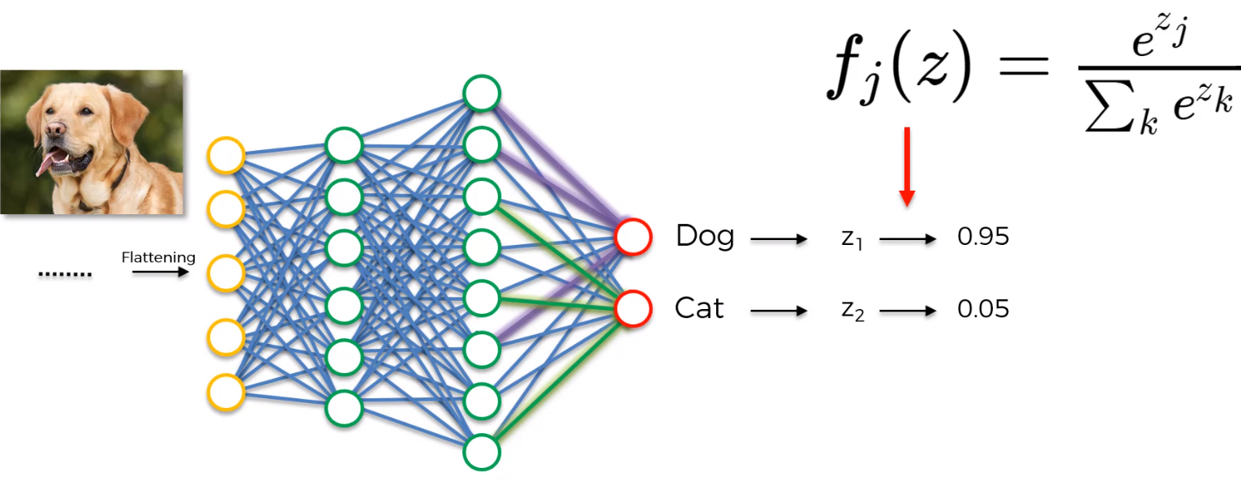

### Cross-Entropy

Recall how we previously in artificial neural networks we had a function called the mean squared error function which we used as the cost function for assessing our natural performance. The our goal was to minimize the MSE in order to optimize our network performance. Well that was our cost function then there and in convolutional neural networks you can still use MSE but a better option in convolutional neural networks after you apply the soft max function turns out to be the cross entropy function and in convolutional neural networks when you apply cross entropy functions not cost called the cost function anymore is called the lost function.

And they are very similar. They're just terminological differences.

And what happens is the lost function is again something that we want to minimize in order to maximize the performance of our network.

#### Example

#### Even though both networks got it wrong in the last one through all three images neural network one was outperforming neural network. So even in the last case it was very it had it it gave dog like a 40 percent chance as opposed to neural network to only give dog a 10 percent chance or neural network one is outperforming across the board when compared to neural network.

And so now we're going to look at the functions that they can measure performance that we've kind oftalked about.

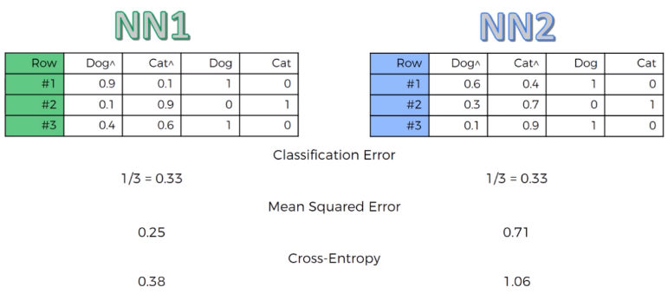

So what errors we can calculate to estimate the performance and monitor the performance of our networks.

One type of error is called the classification error and that is basically just asking it did you get it right or not. Regardless of the probabilities is just DID YOU GET IT RIGHT.

So in both cases for both neural networks each of them they got one. So 33 percent error rate for neural network 1 and 33 percent error rate for neural network 2.

We know that neural network 1 is outperforming neural network. That's why a classification error is not a good measure especially for the purposes of back propagation.

MSE are very straightforward calculations is basically take the sum of squared errors and then just take the average across your observations and that's pretty much it. So for the neural network 1 you get 25 percent for neural network 2 you get 71 percent error rates so as you can see this one is more accurate.

Cross entropy is actually even easier to calculate the mean squared error. Cross entropy gives you 38 percent for neural network 1 and 1.0 6 for neural network 2.

*Why would you use means cross entropy over means square area?*

There's several advantages of cross entropy over mean squared error which are not obvious.

* At the very start of your back propagation your output value is very tiny. At the very start the gradient in your gradient decent will will be very low and you won't be enough. It'll be very hard for the neural network to actually start doing something and start moving around and start adjusting those weights and start move start actually moving in the right direction.  
  When you use something like the cross entropy because it's got that logarithm in it that helps the network assess even a small area like that and do something about it.

Cross entropy will help your neural network get to the optimal state.

This only works when it across entropy is the preferred method only for classification.

If you're talking about things like regression like which we had in artificial neural networks then you would rather go with MSE whereas cross entropy is better for classification.

# AutoEncoder

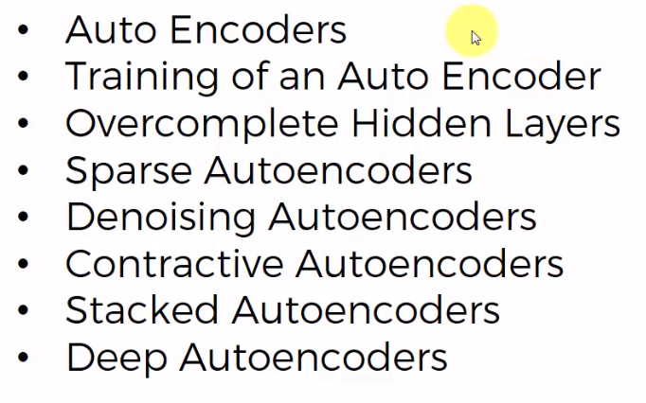The different AutoEncoders will be provided as an overview.

## What Are AutoEncoders

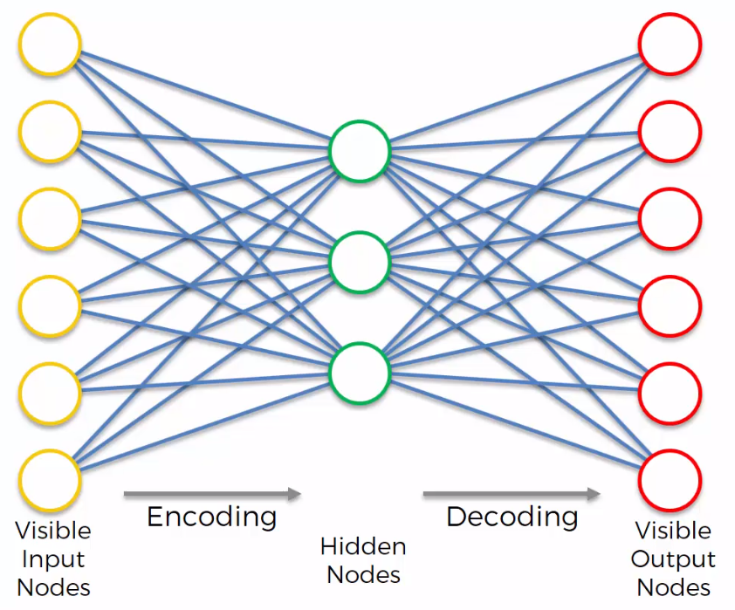

Is a directed types of neural networks.

Set up in such a way that on the output you get values which are equivalent to your inputs and from that you can tell that other coders are not a pure type of unsupervised learning algorithm.

They are a self-supervised deep algorithm because they are comparing it to something on the end remember in Boltzman machines we didn't even have outputs we didn't have to compare to any kind of labels or anything.

Here we are looking for things we're looking for this hidden layer which is also called the coding layer or the bottleneck.

* AutoEncoders can be used for feature detection.
* They can also be used to build powerful recommender systems as you'll see from the practical tutorials in this course
* They can be used to encode data and you could take data with lots and lots of values encoded into a smaller representation and then all you would have to carry around is this or AutoEncoder or this decoder part and your encoded data. So it would take up less space.

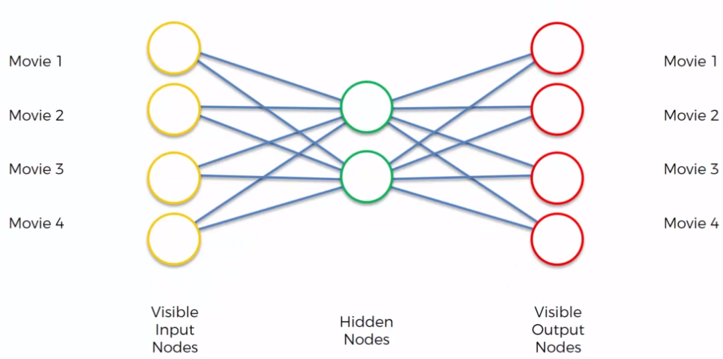Have a look at an example of how they work to understand them better on an intuitive level. There's a simplified AutoEncoder of just four input nodes and two nodes in the hidden.

We're going to be encoding the rating that that people have left for those movies so 1 means a person like that movie and zero means a person didn't like that movie.

First follow training the AutoEncoder which is going to come up with certain connections right away certain weights. This whole example is to prove that it is possible it is possible to take four values and encode them into actually two values.

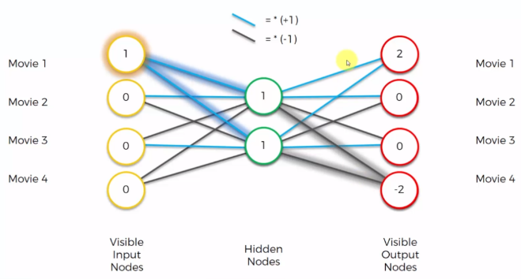We're going to color our synopses in two different colors blue and black or light blue and black where a light blue is basically a multiplication by one.

So your weight is plus one and black is a multiplication by minus 1 so your weight is minus one. You normally use the hyperbolic tangent activation function.

Let's say as an input we've got 1 000. So the person just like moving number one and they disliked the rest of the movies. So what will the hidden nodes look like in that case. Will be this one will turn into one here and this one will turn into one here because Blue is multiplying by one and these zeros they will always just add zero. So basically they're not going to contribute to the hidden nodes.

Now let's calculate each one of the output nodes says go into a tedious process but it's worth it. So there's our input going into these into the hidden node what happens for the top node we multiply by a plus one by plus 1 and we get 2 for this knowledge we get. One times one equals one one times one is one because minus one. You add them up you get zero here you get minus one plus one equals zero and you get minus one minus one equals minus two. So those are your outputs.

But those are actually preliminary outputs in an AutoEncoder. We also have a soft max function on end and we have a tutorial on the soft max function in one of the very early parts of the course.

Basically what SoftMax function does in this case is it takes the highest value. So in this case are two and it turns that into one and everything else into zero. So if you apply a SoftMax you will get one where you see the highest value and then zeros where you see everything else.

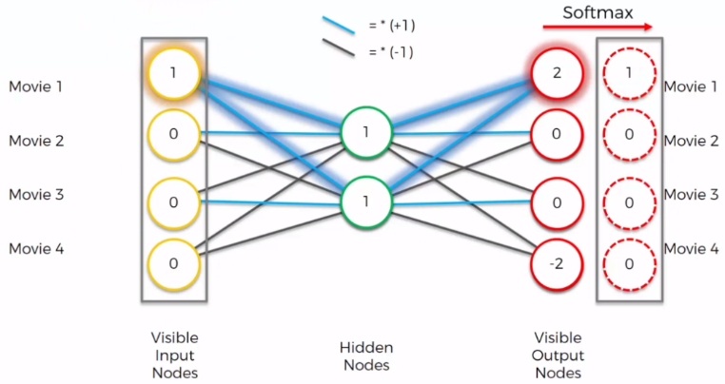And as you can see this result is indeed identical to what we input into our network.

We're just going to look at the results so if you 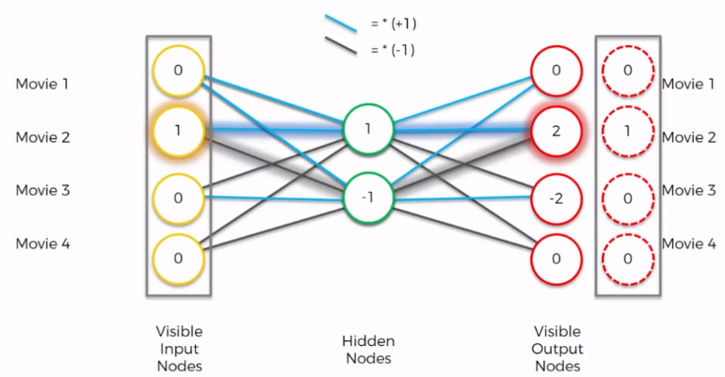input 0 1 0 0 you will see that you get a 2 over here is 0 2 minus 2 0. And when you play this off Max you get 0 1 0 0 again identical.

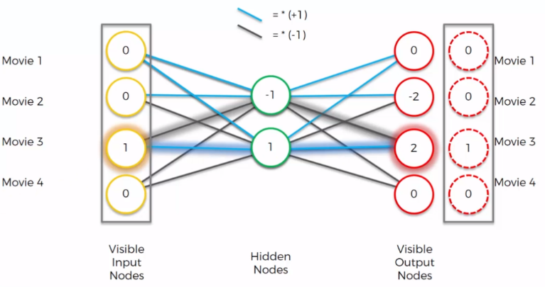If your inputs are one over here you don't want to hear if you inputs a 1 or over here you get a one over here.

As long as in our dataset we've got rows with just three zeros and one 1 we can encode them into a small format where we just have two values so we just have to have these hidden nodes as you can see every state is presented by hidden nodes. Every state is represented by hidden layer and then you just need these weights.

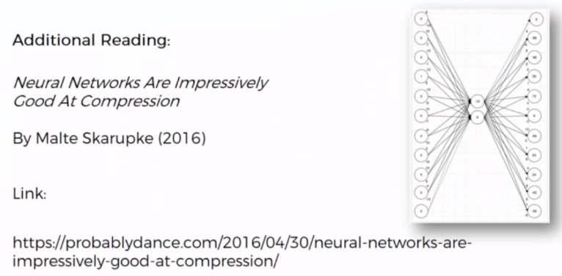So here you can see a much more sophisticated example where you way more so you have one two three four five six seven eight nine 10 11 inputs to hit a nose and 11 outputs and it still works totally fine.

## Note on Biases

The activation of a node in a neural network is determined by the following:



This means when calculating the output of a node, the inputs are multiplied by weights, and a bias value is added to the result. The bias value allows the activation function to be shifted to the left or right, to better fit the data. Hence changes to the weights alter the steepness of the sigmoid curve, whilst the bias offsets it, shifting the entire curve so it fits better. Note also how the bias only influences the output values, it doesn’t interact with the actual input data.

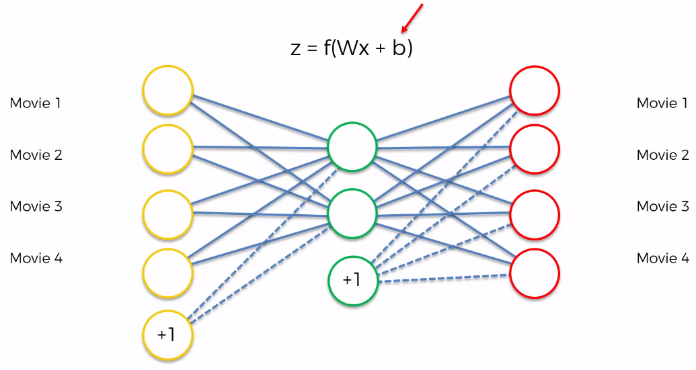

## Training an AutoEncoder

For these six movies and based on those ratings, the AutoEncoder will come up with a way to compress that information and come up with those weights that will allow it to encode or to basically set itself up to be able to autoencoded and decoded in the future.

These are all training steps.

### Overview

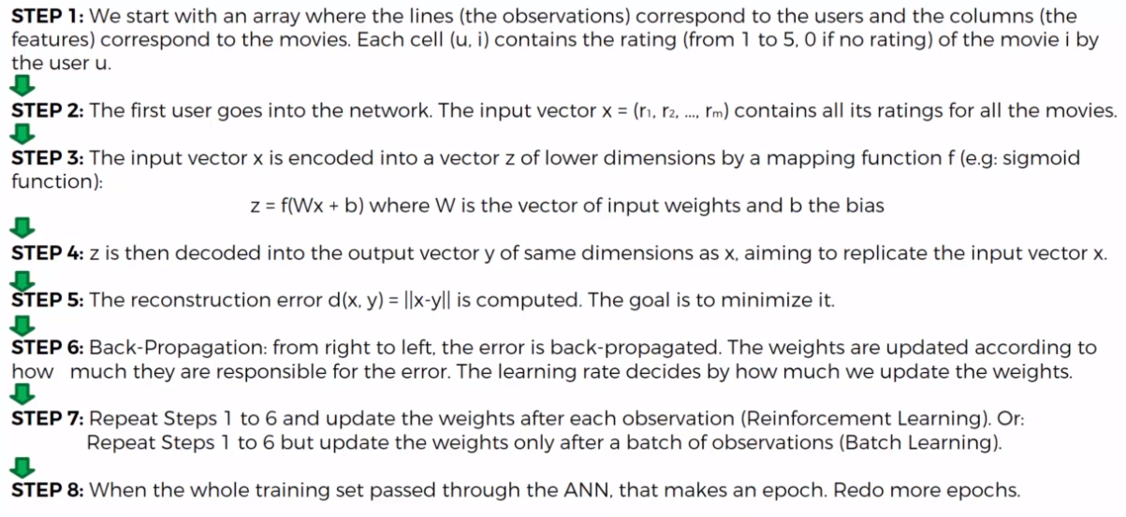

### Step by Step

Let's have a look in a more visual way:

Important to understand that every single row in your dataset is a unique user who rated those movies. 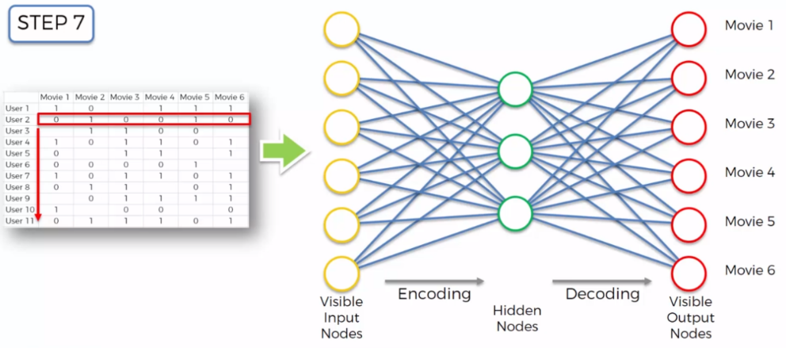

**Step 2** the first user goes into the network. The input vector contains all its ratings for all the movies. For all the ratings of that user for all of the movies.

**Step 3** the input vector is encoded into vectors that have lower dimensions by a mapping function. Usually you'd use a sigmoid or hyperbolic.

**Step 4** Z is then decoded into the output vector of the same dimension as x aiming to replicate the input vector.

**Step 5** We're going to compare the results to the actual ratings for those movies. Calculate the error

**Step 6** propagate back through the network. We will adjust the weights accordingly.

**Next** we will take the next row in our data set and we'll do the same thing and so on and so on and we'll continue through all the rows and then once we're done we move on to Step 8.

Repeat these epochs we continue doing that with our data set depending on how many times we want to do that. And hopefully our training converges to some sort of value.

**Great article and examples**: <https://blog.keras.io/building-autoencoders-in-keras.html>

## Overcomplete Hidden Layers

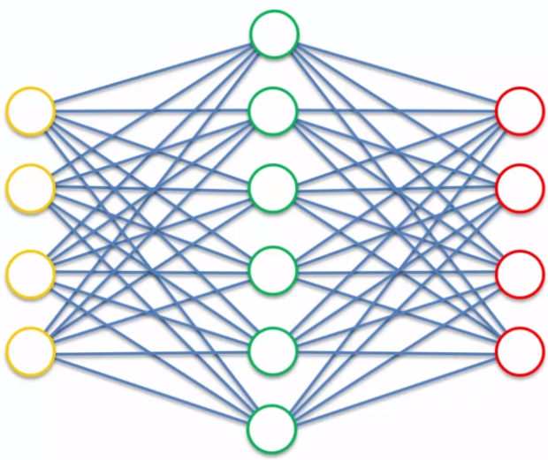*What if we wanted to increase the number of nodes in the hidden lair.*

*But what if we want more features.*

As soon as you give it a hidden layer which is the same size or greater than the input layer it is able to cheat and just have one hidden node is always going the be equal to a specific node on the right and you'll even have some extra nodes that are not being used. And that could be the end process and state that this encoder would end up in after the training and it's going to be just useless is not going to extract any valuable information any valuable features.

So this is definitely a problem. We're going to look at the next 3 tutorials we're going to look at three different approaches that are used to solve that problem.

### Sparse AutoEncoder

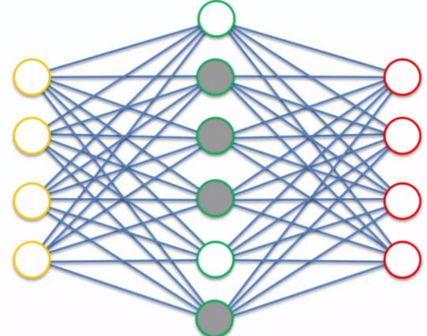When the hidden layer is greater than the input layer a regularization technique is used to introduce sparsity that helps prevent overfitting or stabilizes the algorithm in this case. It introduces a constraint on the last function or a penalty in the lost function and which doesn't allow the AutoEncoder to use all of its hidden layer every single time.

So it simply limits how many hidden nodes can be used prevent the AutoEndoder from cheating when the number of hidden nodes > number of Input nodes. This is done by using tiny weights for the nodes that are not going to be used. During each pass, different hidden nodes may be blocked – it is dynamic.

The essence is because you have so many rows in your data set that are going through at training this whole you are extracting features from each one of these nodes through each one of these nodes. But at the same time not at any given pass you're not using all of these so our encoder cannot cheat because even though it has more nodes in the hidden layer than in the input layer it is not able to use all of them at any given pass.

### Denoising AutoEncoder

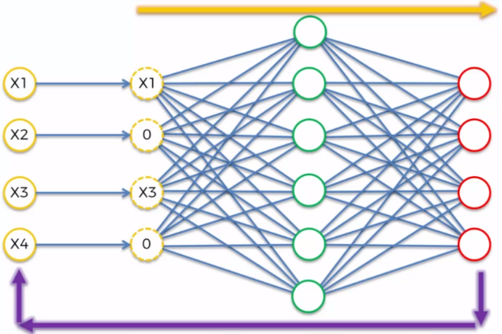It is another regularization technique.

Take input values and move them to the left and replace them with something else. And this something else is a modified version of our input values.

So let's say we have input values X1 sixty three and x 4. Take these inputs and randomly and turn some of them into zeros. It's a parameter you can specify in your in the setup of your own code or it can be half of your inputs that you have are turned into zeros every single time. It happens randomly. It can be different variables.

And then once you put this data through your AutoEncoder which you do in the end is you compare the output not with the modified values but with the original values. That prevents the order encoder from simply just copying those that data or those inputs all the way through to the outputs because it's comparing the output not with the noisy but with the original inputs.

It's important to note that because this happens randomly this type of auto encoder is a sarcastic type of autoencoder.

### Contractive AutoEncoder

Another regularization technique. It leverages the whole training process where information goes through the AutoEncoder. Then we get the outputs and then compare to the inputs. Contractive AutoEncoders add a penalty into this last function that has been propagated by the network and it specifically doesn't allow the AutoEncoder to simply just copy these values across.

How it works how we're not going to go into detail on that because it is very complex.

## Stacked AutoEncoder

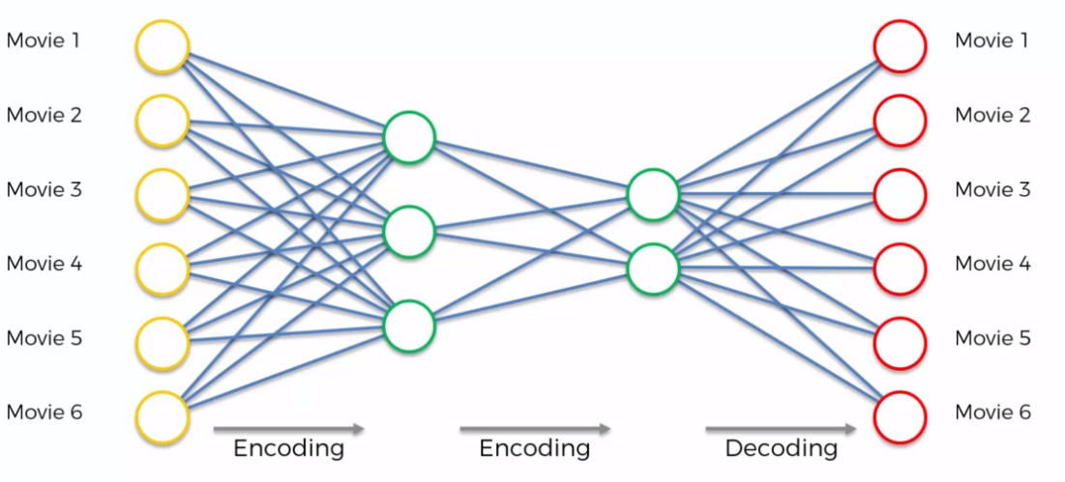It adds two stages of encoding and one stage of decoding. This is a very powerful algorithm. It's been shown that sometimes this model can supersede the results that are achieved by deep belief networks so DBNs ends which is a very important breakthrough because a DBMS are a whole different type of model.

They're based on stacked restricted Boltzmann machines which are undirected neural networks whereas Stacked Autoencoders are directed neural networks so it's it's very big breakthrough that's stacked AutoEncoders can sometimes supersede the results of the belief networks.

## Deep AutoEncoder

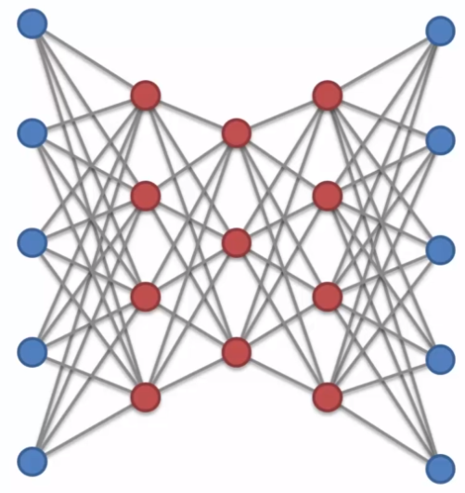One thing that you should be aware of Stacked Autoencoders are not the same thing as deep AutoEncoders and this will become extremely obvious when you see their full picture.

These are restricted Boltzman machines so stacked pre-trained layer by layer rpms.

So basically they are RBMs that are stacked then they're pre-trained layer by layer then they're unrolled then they're fine-tuned with back propagation.

So then you do get directionality and you have back propagation. In essence a deep AutoEncoder comes from RBM stacked AutoEncoder or just normal encoders stacked a deep out encoder is RPMs stacked on top of each other and then certain things are done with them in order to achieve a Autoencoder mechanism.

# Restricted Boltzman Machine

RBM = Restricted Boltzman Machine:

* RBMs are deep belief networks.
* AutoEncoders learns a representation of the inputs and is deterministic; RBMs learn the statistical distribution and is probabilistic (stochastic)
* RBMs are sometimes trickier to train, as they approximate the log-likelihood gradient, while Denoising Autoencoders just use a reconstruction error objective. I've seen some agreement of this opinion in the literature.
* 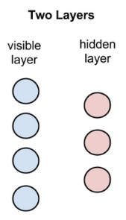RBMs are shallow, two-layer neural nets that constitute the building blocks of deep-belief networks. The first layer of the RBM is called the visible, or input, layer, and the second is the hidden layer.
  + While RBMs are occasionally used, most practitioners in the machine-learning community have deprecated them in favor of generative adversarial networks or variational autoencoders.

Each circle in the graph above represents a neuron-like unit called a node, and nodes are simply where calculations take place. The nodes are connected to each other across layers, but no two nodes of the same layer are linked.

That is, there is no intra-layer communication – this is the restriction in a restricted Boltzmann machine. Each node is a locus of computation that processes input, and begins by making stochastic decisions about whether to transmit that input or not. (Stochastic means “randomly determined”, and in this case, the coefficients that modify inputs are randomly initialized.)

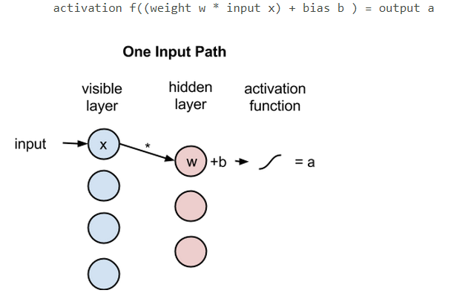Each visible node takes a low-level feature from an item in the dataset to be learned. For example, from a dataset of grayscale images, each visible node would receive one pixel-value for each pixel in one image. (MNIST images have 784 pixels, so neural nets processing them must have 784 input nodes on the visible layer.)

Now let’s follow that single pixel value, x, through the two-layer net. At node 1 of the hidden layer, x is multiplied by a weight and added to a so-called bias. The result of those two operations is fed into an activation function, which produces the node’s output, or the strength of the signal passing through it, given input x.

Next, let’s look at how several inputs would combine at one hidden node. Each x is multiplied by a separate weight, the products are summed, added to a bias, and again the result is passed through an activation function to produce the node’s output.

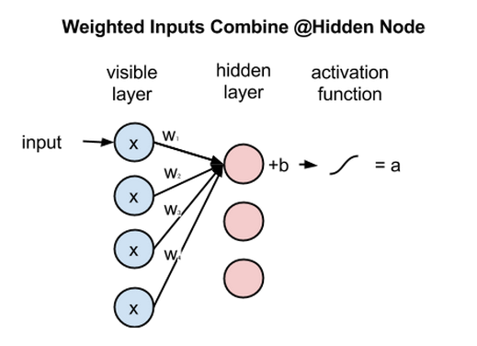Because inputs from all visible nodes are being passed to all hidden nodes, an RBM can be defined as a *symmetrical bipartite graph*.

*Symmetrical* means that each visible node is connected with each hidden node (see below). *Bipartite* means it has two parts, or layers, and the *graph* is a mathematical term for a web of nodes.

At each hidden node, each input x is multiplied by its respective weight w. That is, a single input x would have three weights here, making 12 weights altogether (4 input nodes x 3 hidden nodes). The weights between two layers will always form a matrix where the rows are equal to the input nodes, and the columns are equal to the output nodes.

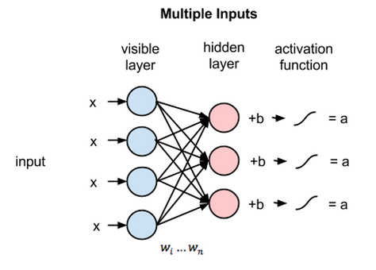Each hidden node receives the four inputs multiplied by their respective weights. The sum of those products is again added to a bias (which forces at least some activations to happen), and the result is passed through the activation algorithm producing one output for each hidden node.

If these two layers were part of a deeper neural network, the outputs of hidden layer no. 1 would be passed as inputs to hidden layer no. 2, and from there through as many hidden layers as you like until they reach a final classifying layer. (For simple feed-forward movements, the RBM nodes function as an *autoencoder* and nothing more.)

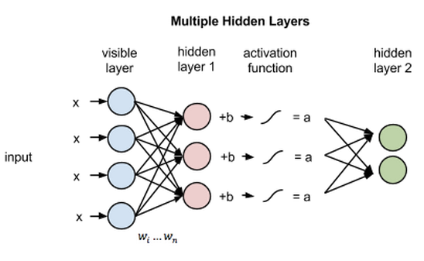

## Reconstruction

In this introduction to restricted Boltzmann machines, we’ll focus on how they learn to reconstruct data by themselves in an unsupervised fashion (unsupervised means without ground-truth labels in a test set), making several forward and backward passes between the visible layer and hidden layer no. 1 without involving a deeper network.

In the reconstruction phase, the activations of hidden layer no. 1 become the input in a backward pass. They are multiplied by the same weights, one per internode edge, just as x was weight-adjusted on the forward pass. The sum of those products is added to a visible-layer bias at each visible node, and the output of those operations is a reconstruction; i.e. an approximation of the original input. This can be represented by the following diagram:

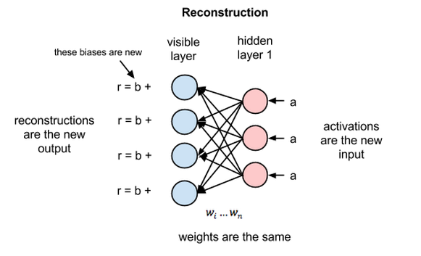

Because the weights of the RBM are randomly initialized, the difference between the reconstructions and the original input is often large. You can think of reconstruction error as the difference between the values of rand the input values, and that error is then backpropagated against the RBM’s weights, again and again, in an iterative learning process until an error minimum is reached.

As you can see, on its forward pass, an RBM uses inputs to make predictions about node activations, or the [probability of output given a weighted x](https://en.wikipedia.org/wiki/Bayes%27_theorem): p(a|x; w).

But on its backward pass, when activations are fed in and reconstructions, or guesses about the original data, are spit out, an RBM is attempting to estimate the probability of inputs x given activations a, which are weighted with the same coefficients as those used on the forward pass. Together, those two estimates will lead you to the joint probability distribution of inputs x and activations a.

Reconstruction does something different from regression, which estimates a continuous value based on many inputs, and different from classification, which makes guesses about which discrete label to apply to a given input example.

Reconstruction is making guesses about the probability distribution of the original input; i.e. the values of many varied points at once. This is known as [generative learning](http://cs229.stanford.edu/notes/cs229-notes2.pdf), which must be distinguished from the so-called discriminative learning performed by classification, which maps inputs to labels, effectively drawing lines between groups of data points.

Let’s imagine that both the input data and the reconstructions are normal curves of different shapes, which only partially overlap.

To measure the distance between its estimated probability distribution and the ground-truth distribution of the input, RBMs use [Kullback Leibler Divergence](https://www.quora.com/What-is-a-good-laymans-explanation-for-the-Kullback-Leibler-Divergence).

KL-Divergence measures the non-overlapping, or diverging, areas under the two curves, and an RBM’s optimization algorithm attempts to minimize those areas so that the shared weights, when multiplied by activations of hidden layer one, produce a close approximation of the original input. On the left is the probability distribution of a set of original input, p, juxtaposed with the reconstructed distribution q; on the right, the integration of their differences.

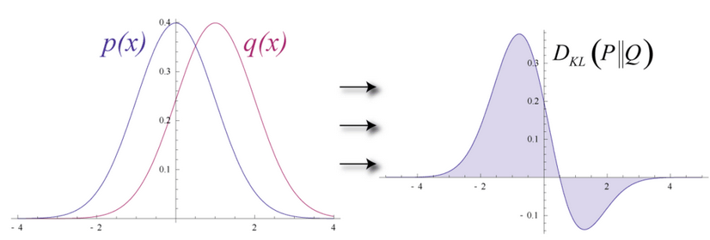By iteratively adjusting the weights according to the error they produce, an RBM learns to approximate the original data. You could say that the weights slowly come to reflect the structure of the input, which is encoded in the activations of the first hidden layer. The learning process looks like two probability distributions converging, step by step.

## Multiple Layers

Once this RBM learns the structure of the input data as it relates to the activations of the first hidden layer, then the data is passed one layer down the net. Your first hidden layer takes on the role of visible layer. The activations now effectively become your input, and they are multiplied by weights at the nodes of the second hidden layer, to produce another set of activations.

This process of creating sequential sets of activations by grouping features and then grouping groups of features is the basis of a feature hierarchy, by which neural networks learn more complex and abstract representations of data.

With each new hidden layer, the weights are adjusted until that layer is able to approximate the input from the previous layer. This is greedy, layerwise and unsupervised pre-training. It requires no labels to improve the weights of the network, which means you can train on unlabeled data, untouched by human hands, which is the vast majority of data in the world. As a rule, algorithms exposed to more data produce more accurate results, and this is one of the reasons why deep-learning algorithms are kicking butt.

Because those weights already approximate the features of the data, they are well positioned to learn better when, in a second step, you try to classify images with the deep-belief network in a subsequent supervised learning stage.

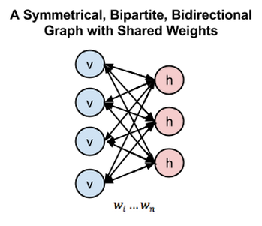While RBMs have many uses, proper initialization of weights to facilitate later learning and classification is one of their chief advantages. In a sense, they accomplish something similar to backpropagation: they push weights to model data well. You could say that pre-training and backprop are substitutable means to the same end.

To synthesize restricted Boltzmann machines in one diagram, here is a symmetrical bipartite and bidirectional graph:

## Use Cases

Restricted Boltzmann machine is an algorithm useful for dimensionality reduction, classification, regression, collaborative filtering, feature learning and topic modeling

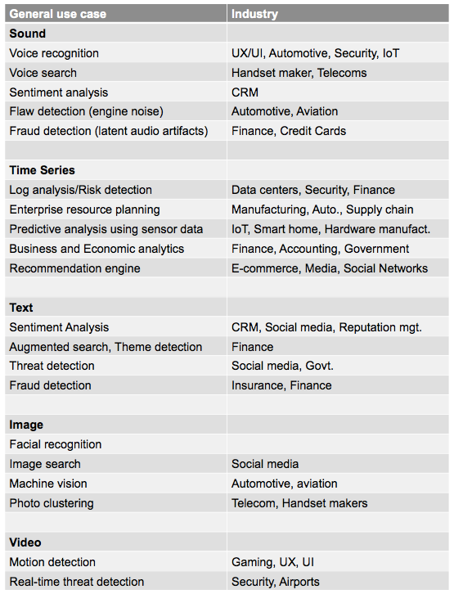

# Variational AutoEncoder

## Introduction

The reason a variational encoder (VAE) is the component of the larger model that creates the dream.

It has mentioned that the idea behind this model is that we are allowing our artificial intelligence to dream and then come up with solutions and in streams.

We've got the image it's coming in. Then it's been encoded with our auto encoder which is VAE. But for now we can just think of this as a normal autoencoder has been encoded.

Then we have the bottleneck or the middle of the encoder or it's also called the latent factor in the middle and then that's information that compressed information is used to is decoded into a reconstructed frame as you can see it's the quality has dropped that here.

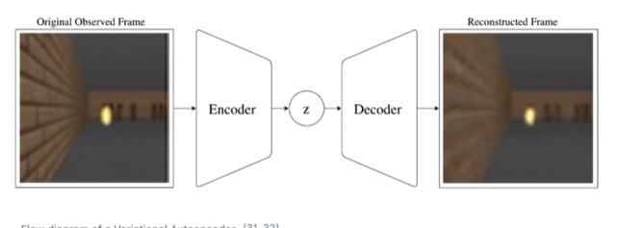

Now we could do this with a normal auto encoder and indeed we could code encoded and then decode it. And we would have a compressed environment so that's one of the benefits we'd have like a compressed version of our original environment. And that's one of the benefits of using an autoencoder is that we can take a environment with millions or sometimes in some cases it goes up to billions of parameters. Basically an autoencoder allows you to compress this environment into from billions of parameters really reduce the parameters and extract features that really matter.

The VAE has a stochastic (random sampling) component allows for various different iterations (dreaming) from all of them. It increases the opportunity to learn like dreaming.

## VAE

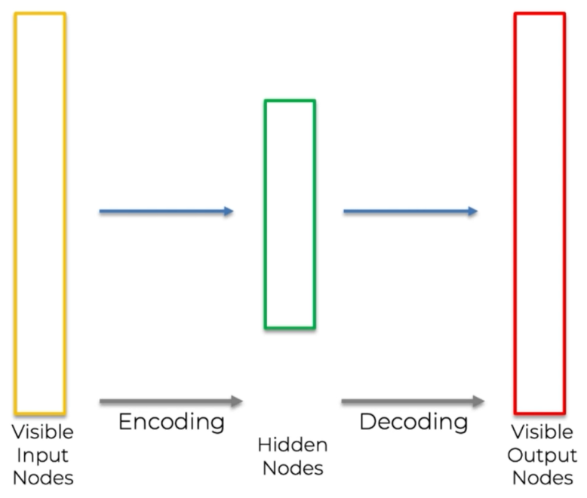This is the same regular autoencoder we have seen before, just in a different format.

*What is the difference between a normal autoencoder and a VAE?*

In a VAE we want to add some stochasticy (add some randomness to the latent vector (the Hidden Node in a regular autoencoder.)

We're going to take all inputs and we're going to map them onto a distribution and that will allow us to have randomness or stochasticity in a latent vector and reconstruct many different environments or have some randomness every time we decode the spectrum.

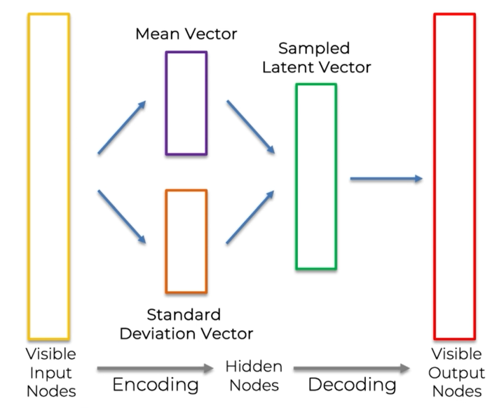All we need to do is rather than mapping straight to the latent vector we're going to first map our inputs onto two vectors one of them is going to be the mean vector. So that's the mean of our standard distribution. And then we get to have the standard deviation vector. These two vectors we're going to sample our latent vector every single time.

The sampled latent vector is trained to get a slightly varying latent back to every single time we decode.

After once you know what how auto encoders work this step towards variational is very simple.

Effectivity instead of mapping onto a layout and back to straight away we're mapping onto a mean vector to stand division that we're sampling the latent vector and in essence turns out that we are mapping our inputs onto a distribution from which we sample in order to then proceed with the decoding.

## Reparameterization Trick

*How do you train a variation and what will happen when we run back for progression?*

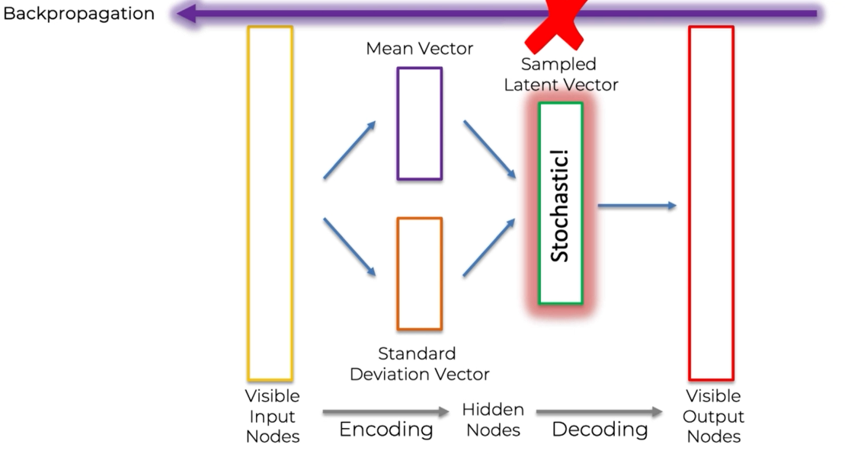This is where the Reparameterization Trick comes in handy

*Z* our sample data vector is going to be a combination of the mean vector the mu plus the standard deviation of Sigma multiplied by Epsilon where Epsilon is going to be the stochastic node.

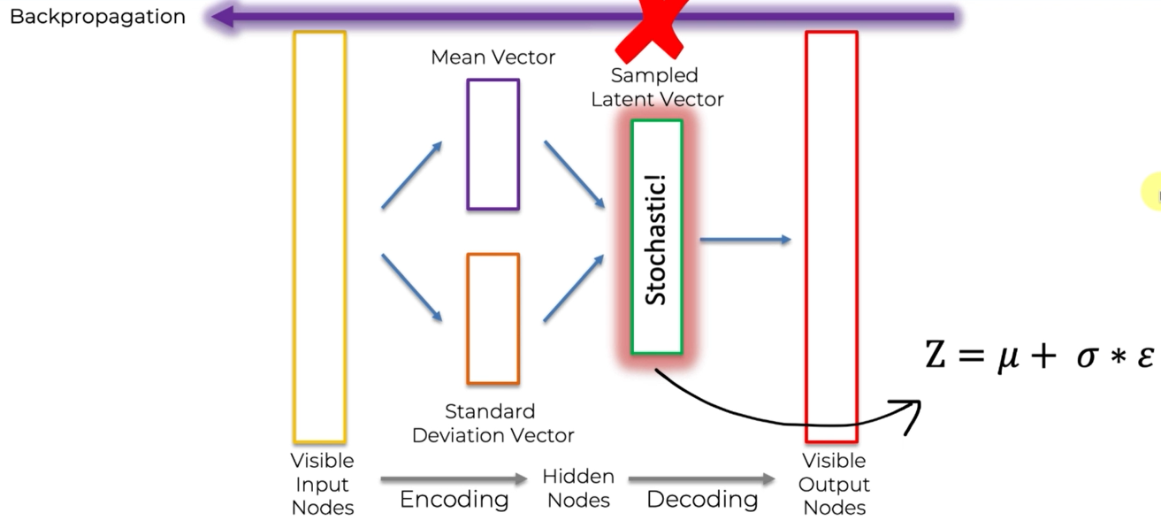

So rather than performing stochasticity or performing the sampling in the latent vector itself we're going to separate out the sampling into its own separate node and that way is going to allow us to run propagation.

So let's have a look in a schematic or at a schematic or a presentation of this so we can so it becomes a bit clearer.

As you can see we're taking the mean vector and standard deviation vector we're using them inside the latent vector of the sample plate and vector. We're using them inside here to perform the sampling of the latent vector and then we're proceeding with the decoding.

So this is where the reparametrization trick trick comes to the rescue because what we're doing now is rather than doing the sampling within this node within this vector we're actually separating out the sampling into its own separate node.

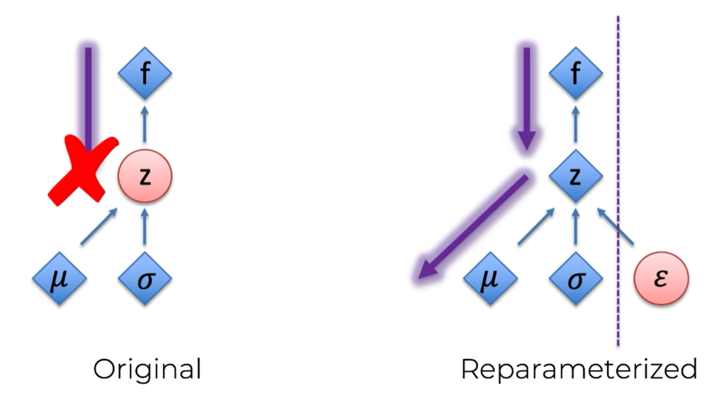So Epsilon is just going to be a way for us to introduce randomness into this equation so it's just great to be a standard deviation is that a distribution offer.

There's nothing special about it we don't actually need to train it whereas everything else that we do want to train is easily accessible

The randomness is separate out in its own node and we don't want to train it anyway whereas everything we do want to train is very straightforward for back propagation.

# Implementing the CNN-VAE

In this section, we will build a CNN-VAE, i.e. a Variational AutoEncoder with a CNN encoding the input states (frames). The most important to understand here is that in this section, we will give the AI the ability to dream.

Here is the plan of Attack to tackle this implementation:

1. Initializing all the parameters and variables of the CNN-VAE class
2. Building the Encoder part of the VAE
3. Building the "V" part of the VAE
4. Building the Decoder part of the VAE
5. Implementing the training operations

## Introduction to CNN-VAR

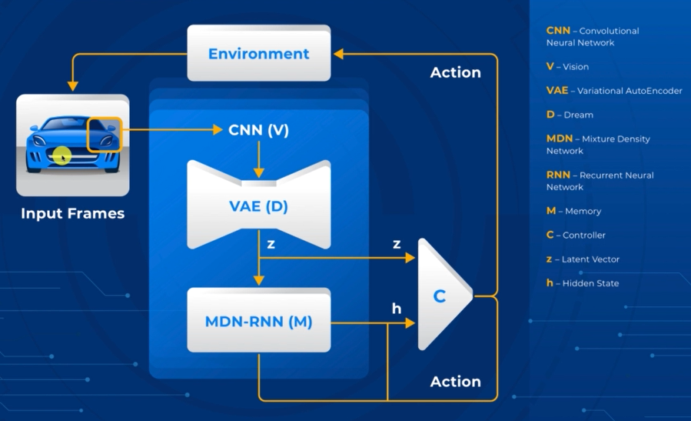

What's important to understand is that the CNN allows the vision of the model so that the model is able to see just like a human the input frames on the game on the car racing game just as if it was playing the game like some humans would play video games.

And then the VAE is the part that dreams remember that the specific feature of this new Full World Model is that it is a model that can dream because the core added value of the full world model is that it gains better performance.

Inside the dream that is inside the reconstructed environment happening in the VAE.

The model will first encode the real images the real input frames into a latent vector and then from the latent vector that we will reconstruct the images as in a dream.

We're going to build a big class that is going to contain not only the full architecture of the convolutional variational autoencoder but also we will implement the training operations.

So this will take about 80 lines of code. We're going to build in this implementation you know in this huge convolutional the class is going to be exactly the same architecture as the one given in this article. (<https://worldmodels.github.io/> )

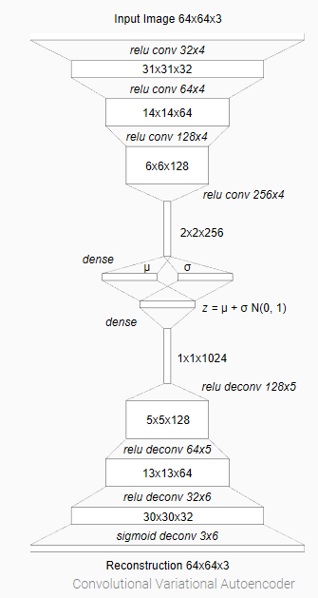The first convolutional layers of 32 64 128 and 256 sensor input then will create the latent vector which will be a one dimensional vector of course but composed of 1024 elements which will be the result of the flattening after the convolutions.

And then we'll use the deconvolution or also called to transpose convolutions or even the inverted convolutions to recreate or to reconstruct the images from the latent vectors.

The input images coming from the environment and all this process happens to create in the end the dream.

All right so if you're ready now we're going to move on to Python to build all this plus the training operations.

Let's start with the first code section importing the libraries.So we will only need two libraries here to build this convolutional the class.And these are first non-Thai for which will give the shortcut and P.And of course as we've just said of flow for which we will give the shortcut T F and perfect that'sit.

That's only what we'll need to create our convolutional the Emo.And now we're ready to build the convolutional emotional and we'll build that as you can see withina class which will call count the.But this is going to be a big code section no big class with a lot of things to do including buildingthe whole architecture which as you saw is not a simple architecture.And also the training operations.

## Build ConvVAE

# Building the CNN-VAE model within a class

class ConvVAE(object):

# Initializing all the parameters and variables of the ConvVAE class

# Setting defaults below – they will be changed later

# kl_tolerance represents the sum of 2 losses: MSE and KL Loss which stands for Kullback-Leiber Loss

# is_training if FALSE for inference mode and TRUE for training mode

# reuse is a tensorflow variable that allows to to reuse a variable or container of variables – it is for convenience.

def __init__(self, z_size=32, batch_size=1, learning_rate=0.0001, kl_tolerance=0.5, is_training=False, reuse=False, gpu_mode=False):

# Initialize the variables

# So make sure you understand the difference. self.z_size is a variable of the object. z_size is the value of the argument in the def__init__.

self.z_size = z_size

self.batch_size = batch_size

self.learning_rate = learning_rate

self.kl_tolerance = kl_tolerance

self.is_training = is_training

self.reuse = reuse

with tf.variable_scope('conv_vae', reuse=self.reuse):

if not gpu_mode:

with tf.device('/cpu:0'):

tf.logging.info('Model using cpu.')

self._build_graph() # We will build this method – see below

else:

tf.logging.info('Model using gpu.')

self._build_graph()

self._init_session() # initializes session

# Making a method that creates the VAE model architecture itself

def _build_graph(self):

self.g = tf.Graph() # must create object variable

with self.g.as_default():# build the VAE architecture in the graph

# Use the architecture illustration displayed previously to build the model

# Notice the **input image** from the illustration has inputs of 64x64x3 is set to variable x below

# tensorflow placeholders are generally used with images.

# Recall images start as 1-255 but are transformed to 0-1 so they are decimals or floats

self.x = tf.placeholder(tf.float32, shape=[None, 64, 64, 3]) # 3 for RGB images

# Building the **Encoder** part of the VAE

# stride typically = 2

h = tf.layers.conv2d(self.x, 32, 4, strides=2, activation=tf.nn.relu, name="enc_conv1")

# h becomes the input of the following layers – makes sense

h = tf.layers.conv2d(h, 64, 4, strides=2, activation=tf.nn.relu, name="enc_conv2")

h = tf.layers.conv2d(h, 128, 4, strides=2, activation=tf.nn.relu, name="enc_conv3")

h = tf.layers.conv2d(h, 256, 4, strides=2, activation=tf.nn.relu, name="enc_conv4")

# flatten the information into a 1D vector – tensorflow makes this a simple operation

# -1 means a 1D vertical vector

h = tf.reshape(h, [-1, 2*2*256])

# Building the "V" part of the VAE – the **Latent Vector** Z – See note below

self.mu = tf.layers.dense(h, self.z_size, name="enc_fc_mu") # fc = fully connected

# Uncertain why the next 2 lines are required to calculate u

self.logvar = tf.layers.dense(h, self.z_size, name="enc_fc_log_var")

self.sigma = tf.exp(self.logvar / 2.0)

# get a random number from the normal distribution

self.epsilon = tf.random_normal([self.batch_size, self.z_size])

self.z = self.mu + self.sigma * self.epsilon # see formula in illustration above

# Building the **Decoder** part of the VAE – Follow the illustration again (inverted convolutions)

h = tf.layers.dense(self.z, 1024, name="dec_fc") # another fully connected layer (dense)

h = tf.reshape(h, [-1, 1, 1, 1024]) # 1024 elements

# 128 filters of size 5x5

h = tf.layers.conv2d_transpose(h, 128, 5, strides=2, activation=tf.nn.relu, name="dec_deconv1")

h = tf.layers.conv2d_transpose(h, 64, 5, strides=2, activation=tf.nn.relu, name="dec_deconv2")

h = tf.layers.conv2d_transpose(h, 32, 6, strides=2, activation=tf.nn.relu, name="dec_deconv3")

# 3 filters size 6 x 6 – final layer – it is the reconstructed images – new variable y – sigmoid is the final activation

self.y = tf.layers.conv2d_transpose(h, 3, 6, strides=2, activation=tf.nn.sigmoid, name="dec_deconv4")

# Above the brain for the AI – the ability to dream – has been built.

# Below the AI is trained. Reduces the loss between the predictions (self.y) and the target (self.x)

# MSE and KL loss

# Implementing the training operations

# Recall is_training is a parameter of the class function

if self.is_training:

# Define a new object variable of stochastic gradient descent to reduce the loss

# initial value = 0, trainable initialized as FALSE

self.global_step = tf.Variable(0, name='global_step', trainable=False)

# Calculate the losses

# MSE loss is straightforward in 2 steps:

# Calculate the sum of the square differences between the predictions and the target.

# This is done manually! See the MSE Note below.

self.r_loss = tf.reduce_sum(tf.square(self.x - self.y), reduction_indices = [1,2,3])

# Get the mean of the calculation performed above.

self.r_loss = tf.reduce_mean(self.r_loss)

# Calculate KL loss – do not clearly understand this code logic

# Not going to explain the formula, just implement it.

# It is so complex that it will done in three steps.

self.kl_loss = - 0.5 * tf.reduce_sum((1 + self.logvar - tf.square(self.mu) - tf.exp(self.logvar)), reduction_indices = 1)

self.kl_loss = tf.maximum(self.kl_loss, self.kl_tolerance * self.z_size)

self.kl_loss = tf.reduce_mean(self.kl_loss)

# The global loss is the sum of the MSE and LK_loss

self.loss = self.r_loss + self.kl_loss

# New variable called lr

self.lr = tf.Variable(self.learning_rate, trainable=False)

# New variable called optimizer

self.optimizer = tf.train.AdamOptimizer(self.lr)

#

# Calculate the gradient (grads)

grads = self.optimizer.compute_gradients(self.loss)

# Apply gradients on the loss to reduce it by updating the weights in our VAE neural network according to how they contributed to that loss error.

self.train_op = self.optimizer.apply_gradients(grads, global_step=self.global_step, name='train_step')

self.init = tf.global_variables_initializer()

### Notes

self.x = tf.placeholder(tf.float32, shape=[None, 64, 64, 3]):

The first dimension represents the number of samples (images in your case). The reason why you do not want to hardcode a specific number there is to keep things flexible and allow for any number of samples. By putting None as the first dimension of the tensor you enable that. Consider the following 3 very common actions:

1. **Batch training**: You are going to use batches of samples of relatively small length (32, 64, ...)
2. **Train evaluation**: evaluation of performance over all training samples
3. **Test evaluation**: evaluation performance over all testing samples

All of these will work with a different number of samples in general. However, you do not have to worry because the *None* got you covered.

Latent Vector

We've just flattened the result of these four convolutions into a one dimensional vector of 2x2x256 and that would be the final latent vector of a classic encoder. But we were building a variational autoencoder and instead of returning this latent vector Z in a deterministic way as a result of these four convolutions, sample it from a factor Gaussian distribution of mean *u* and variance Sigma.

Make two separate fully connected layers *u* and sigma. Build them with the dense function by tensorflow. Dense is always the name of the classes and functions to build fully connected layers and then using the random normal distribution by tensorflow generate some numbers from a normal distribution meaning Gaussian distribution of mean zero and variance one. Add this to obtain the final latent vector which is the result of some stochastic operations.

It's given in a stochastic way as opposed to a deterministic way. Build these two fully connected layers and then sample our final Latent factor z from the Gaussian distribution.

Conv2d Choice

How do you determine to use conv2d over other options such as conv2D or others listed in the tensorflow documentation?

Both will give you the same convolutional layer. So it only depends on whether you want to work with functions or classes/objects:

* conv2d() is the function
* conv2D() is the class

dense or Dense?

In setting the variable mu, tf.layers.dense was selected. How do you determine to use dense of Dense options?

Both will give you the same fully connected layer. So it only depends on whether you want to work with functions or classes/objects:

* dense() is the function
* Dense() is the class

MSE

self.r_loss = tf.reduce_sum(tf.square(self.x - self.y), reduction_indices = [1,2,3])

But then that's not all we have to specify on which indices we want to operate these sums and actually know since x and y both have three dimensions corresponding to remember the width the height and the RGB dimension because we're dealing with colored images. Specify that we are summing along the three axis corresponding to these three dimensions. Therefore add as the second argument of to reduce_sum function is reduction indices equals in square brackets the three indexes of the three dimensions.

There is trap here. The first index corresponds to the batch so that's not where we want to start with. The first axis will have index 1. The second axis will have the index two and the third axis corresponding to the RGB dimension will have the index three. Now we are summing the square differences along the three axes.

# Recurrent Neural Network

To get started right away, just tap any placeholder text (such as this) and start typing.

View and edit this document in Word on your computer, tablet, or phone. You can edit text; easily insert content such as pictures, shapes, or tables; and seamlessly save the document to the cloud from Word on your Windows, Mac, Android, or iOS device.

“Quote”

Want to insert a picture from your files or add a shape, text box, or table? You got it! On the Insert tab of the ribbon, just tap the option you need.

Find even more easy-to-use tools on the Insert tab, such as to add a hyperlink, insert a comment, or add automatic page numbering.

# Heading 2

* Use styles to easily format your Word documents in no time. For example, this text uses the List Bullet style.
* On the Home tab of the ribbon, check out Styles to apply the formatting you want with just a tap.

|  |  |  |
| --- | --- | --- |
|  | Column Heading | Column Heading |
| Row Heading | Text | 123.45 |
| Row Heading | Text | 123.45 |
| Row Heading | Text | 123.45 |